# 

**SOW 2 Design Document, Release 12.6.1**

**June 26, 2012**

Table of Contents

1 Login Screen 6

2 Dashboard 7

2.1 Dashboard Screen 7

3 User Administration & Role-Based Data Access 8

3.1 User Administration 8

3.2 User Roles 8

3.2.1 Franchise User Level 8

3.2.2 Franchise Owner Level 8

3.2.3 Coach Level 9

3.2.4 Corporate Level 9

3.3 Role-Based Data Access 9

4 Existing CRM Module Updates 10

4.1 Existing CRM “Home” Screen 10

4.2 Updated CRM “Accounts” Screen (aka CRM “Home” Screen) 10

4.2.1 Screen Changes 11

4.2.2 Database Changes 11

4.2.3 Data Access by User-Level 11

4.3 Updated CRM “Add Account” Screen 13

4.3.1 Screen Changes 13

4.3.2 Database Changes 14

4.3.3 Data Access by User-Level 15

4.4 Updated CRM “Edit Account” Screen 15

4.4.1 Screen Changes 16

4.4.2 Database Changes 17

4.4.3 Data Access by User-Level 17

4.5 Updated CRM “Contacts” Screen 18

4.5.1 Screen Changes 18

4.5.2 Database Changes 18

4.5.3 Data Access by User-Level 19

4.6 Updated CRM “Add Contact” Screen 20

4.6.1 Screen Changes 20

4.6.2 Database Changes 20

4.6.3 Data Access by User-Level 20

4.7 Updated CRM “Edit Contact” Screen 21

4.7.1 Screen Changes 21

4.7.2 Database Changes 21

4.7.3 Data Access by User-Level 21

4.8 Updated CRM “Opportunities” Screen 22

4.8.1 Screen Changes 22

4.8.2 Database Changes 22

4.8.3 Data Access by User-Level 22

4.9 Updated CRM “Add Opportunity” Screen 23

4.9.1 Screen Changes 23

4.9.2 Database Changes 23

4.9.3 Data Access by User-Level 23

4.10 Updated CRM “Edit Opportunity” Screen 24

4.10.1 Screen Changes 24

4.10.2 Database Changes 24

4.10.3 Data Access by User-Level 24

4.11 CRM “Documents” Screen 24

4.11.1 Screen Changes 25

4.11.2 Database Changes 25

4.11.3 Data Access by User-Level 25

4.12 CRM “Attach New Document” Screen 25

4.12.1 Screen Changes 26

4.12.2 Database Changes 26

4.12.3 Data Access by User-Level 26

4.13 CRM “Attach New Document with Details” Screen 26

4.13.1 Screen Changes 27

4.13.2 Database Changes 27

4.13.3 Data Access by User-Level 27

4.14 CRM “Edit Document” Screen 27

4.14.1 Screen Changes 28

4.14.2 Database Changes 28

4.14.3 Data Access by User-Level 28

5 Sandler Reports 29

5.1 Dashboard showing reports “drop down” selection 29

5.2 New Appointments by Source (by Month) 30

5.2.1 Summary Screen 30

5.2.2 Drill Down Screen 32

5.3 New Clients by Product Type (by Month) 33

5.3.1 Summary Screen 33

5.3.2 Drill Down Screen 35

5.4 New Client Quantity and Average Contract Price (by Month) 36

5.4.1 Summary Screen 36

5.4.2 Drill Down Screen 39

5.5 Class Headcount by Course and Industry (by Month) 42

5.5.1 Summary Screen 42

5.5.2 Drill Down Screen 45

5.6 Actual Dollars Booked and Comparison to Goal (by Month) 47

5.6.1 Data required 47

5.6.2 Data Display by User-Level 48

5.7 Average Length of Time for Active Clients (by Industry) 48

5.7.1 Data required 49

5.7.2 Data Display by User-Level 49

6 Benchmark Reports 50

7 Product Reports 50

8 Email Functionality 50

9 Logout 50

9.1 Current Logout Screen 50

9.2 Corrected Logout Screen 51

**Table of Figures**

Figure 1‑1: Screen Shot – Login Screen 6

Figure 1‑2: Login – No User Name or Password Error Message 6

Figure 1‑3: Login – Incorrect User Name or Password Error Message 7

Figure 2‑1: Screen Shot – Dashboard Screen 7

Figure 3‑1: User Roles 8

Figure 4‑1: Screen Shot – Existing CRM “Home” Screen 10

Figure 4‑2: Screen Shot – Updated CRM “Accounts” Summary Screen [aka – “Home” Screen] 11

Figure 4‑3: Screen Shot – Add Account Screen 13

Figure 4‑4: Screen Shot – CRM Edit Account Screen 16

Figure 4‑5: Screen Shot – CRM Contacts Screen 18

Figure 4‑6: Screen Shot – CRM Add Contact Screen 20

Figure 4‑7: Screen Shot – CRM Edit Contact Screen 21

Figure 4‑8: Screen Shot – CRM Opportunities Screen 22

Figure 4‑9: Screen Shot – CRM Add Opportunity Screen 23

Figure 4‑10: Screen Shot – CRM Edit Opportunity Screen 24

Figure 4‑11: Screen Shot – CRM Documents Screen 25

Figure 4‑12: Screen Shot – CRM Add Document Screen 26

Figure 4‑13: Screen Shot – CRM Document Summary Screen 27

Figure 4‑14: Screen Shot – CRM Edit Document Screen 28

Figure 5‑1: Screen Shot – Dashboard Screen with Reports Dropdown 29

Figure 5‑2: Screen Shot - New Appointments by Source (by Month) 30

Figure 5‑3: Screen Shot – New Appoints by Source Drill Down 32

Figure 5‑4: Screen Shot – New Clients by Product Type (by Month) 34

Figure 5‑5: Screen Shot – New Clients by Product Type, Drill Down 35

Figure 5‑6: Screen Shot – New Client Quantity & Average Contract Price (by Month) 37

Figure 5‑7: Screen Shot – New Client Quantity & Average Contract Price Drill Down 39

Figure 5‑8: Screen Shot – Class Headcount by Course & Industry (by Month) 42

Figure 5‑9: Screen Shot – Headcount by Course & Industry Drill Down 45

Figure 5‑10: Screen Shot – Actual Dollars Booked and Comparison to Goal (by Month) 47

Figure 5‑11: Screen Shot – Average Length of Time for Active Clients (by Industry) 49

Figure 9‑1: Screen Shot – Incorrect Logout Screen 50

Figure 9‑2: Screen Shot – Correct Logout Screen 51

# Login Screen

The Login Screen shown below will be presented to every user when the application is first accessed.

Users will be given a **User Name** and **Password** by their System Administrator. Details of the User Administration will be discussed in Section 3 of this document.

Using valid credentials, a user enter their **User Name** and **Password**, and then click “LOGIN” to access the main page of the application as seen in Section 2 of this document.

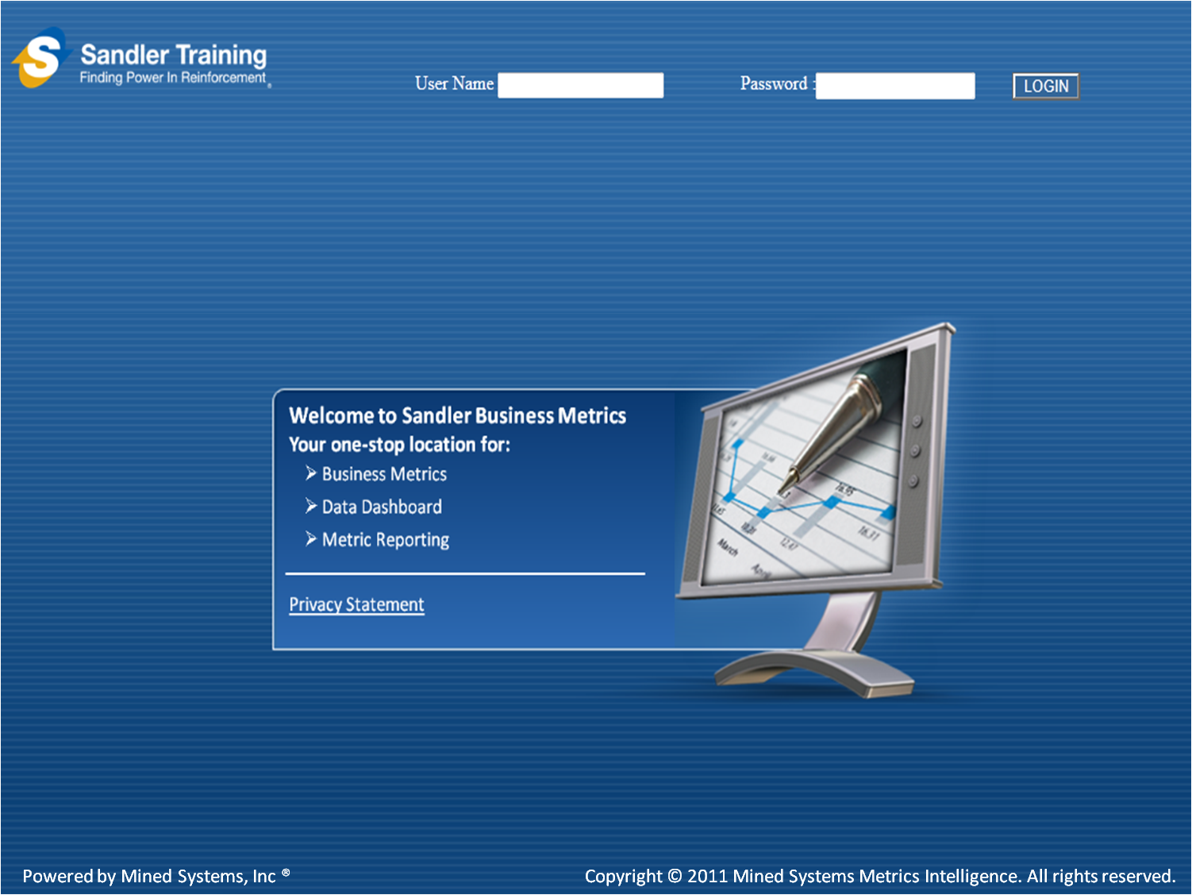

Figure 1‑1: Screen Shot – Login Screen

If the user does not enter a “User Name” or “Password” and simply clicks the “LOGIN” button, the application will provide an error indicating that a “Username” and “Password” are required as shown in Figure 1‑2 below.

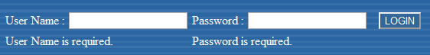

Figure ‑: Login – No User Name or Password Error Message

After entering a “User Name” and “Password” and clicking “LOGIN”, if the user credentials don’t match with the application credentials, an error message will be displayed as shown in Figure 1‑3 below.

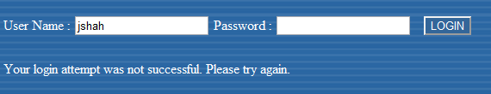

Figure ‑: Login – Incorrect User Name or Password Error Message

# Dashboard

The user will be presented with the 6 reports shown in Section 2.1 below. When the user clicks on the “Dashboard” button, they will be brought back to the screen shown in Section 2.1 below.

In addition, the “Benchmarks” reports and the “Products” reports will be disabled for this release of the application.

## Dashboard Screen

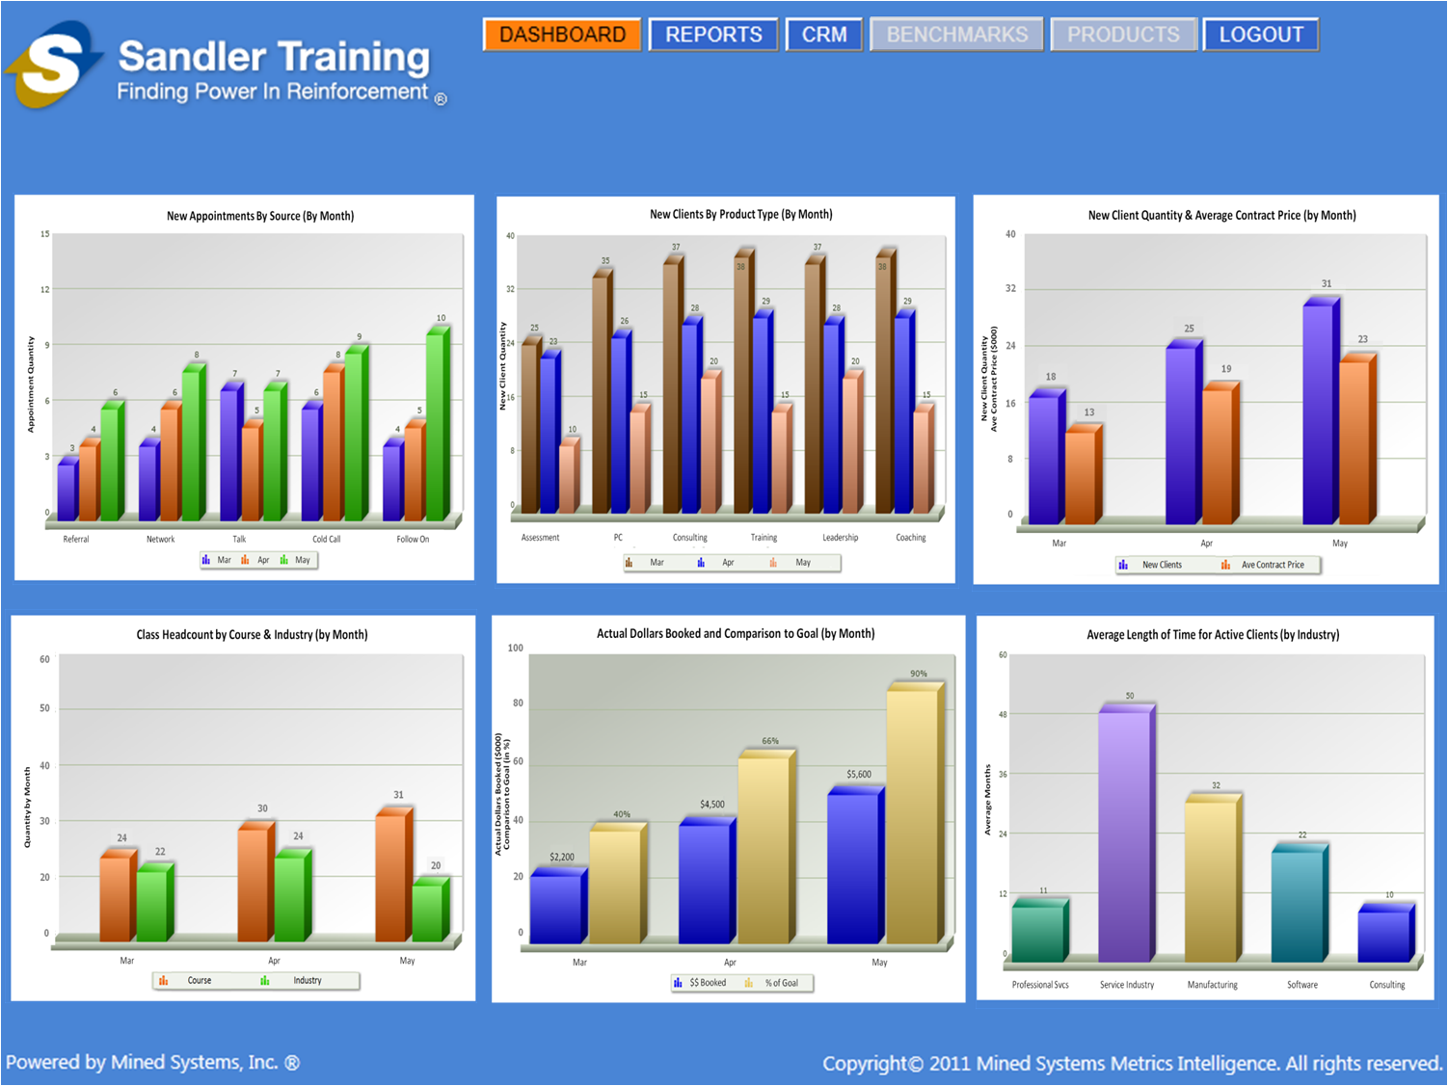

Figure 2‑1: Screen Shot – Dashboard Screen

# User Administration & Role-Based Data Access

## User Administration

The **User Name** and **Password** functionality will be used to define and administer the data within the site, based upon the user roles identified here, and defined in Sections 3.1 through 3.4 of the document:

* Franchise User
* Franchise Owner
* Coach
* Corporate

For this release of the application, the administration of user names and passwords will be handled as a “back-office” function [e.g. there will NOT be a “User Administration” screen built to add/modify/delete users]. Instead, the add/modify/delete capability for the initial set of “pilot users” defined for this release will be processed by the Mined Systems team directly in the database.

## User Roles

Figure 3‑1 below indicates the desired user roles within the application which equates to the data access capability. The capabilities and functionality of the users, and the user-levels, are described in the following subsections. Further details of the specific data displayed [based on the user level] are described in each of the “Report” subsections in Section 5 of this document.



Figure 3‑1: User Roles

### Franchise User Level

* Only add/view their own data within the Franchise
* Does NOT have visibility to data entered by other Franchise users within the Franchise
* Does NOT have visibility to data outside of the Franchise

### Franchise Owner Level

* Add/view data within the Franchise
* Has visibility of all summary data [for all Franchise users] within the Franchise
  + Has drill down visibility to individual user data for all Franchise users within the Franchise
* Has visibility of specific Franchise summary data for all other Franchises within the Region
  + Does NOT have drill down visibility into User level data within the other Franchises within the Region
* In a future release, will have the ability to add/modify/delete users at the “User Level” within the Franchise

### Coach Level

* Has visibility of all summary data within their Region
  + Has drill down visibility to Franchise level summary data for all Franchises within their Region
  + Has drill down visibility to Franchise level summary data for any specific Franchise within their Region
  + Has drill down visibility to user data within all Franchises within their Region
* Has visibility of specific summary data for all other Regions
  + Does NOT have drill down visibility into Franchise level data within other Regions
  + Does NOT have drill down visibility into User level data within other Franchises within other Regions
* In a future release, will have the ability to add/modify/delete users at the “Franchise Owner Level” within the Region

### Corporate Level

* Has visibility of all summary data throughout the entire organization
  + Has drill down visibility to Region level summary data for all Regions
  + Has drill down visibility to Region level summary data for any specific Region
  + Has drill down visibility to Franchise level summary data for all Franchises for all Regions
  + Has drill down visibility to Franchise level summary data for any specific Franchise, within any specific Region
  + Has drill down visibility to User level data for any specific Franchise, within any specific Region

In a future release, will have the ability to add/modify/delete users at the “Coach Level” for any of the Regions

## Role-Based Data Access

The general approach to role-based data access is that as data are entered within the CRM module, the data being written to the database must be tagged to the user who entered it for reporting and “data aggregation” purposes. Every record being written to the database [or every document being uploaded] needs to be tagged with the following:

* Unique ID of the person who entered the data (Franchise User, Franchise Owner, Coach, or Corporate User)
* Franchise ID [the unique ID of the Franchise that the Franchise User belongs to]
* Region ID [the unique ID of the Region that the Franchise belongs to]

By “tagging” the data when it is entered, we will be able to control data access based upon the assigned roles defined here. As an example, the data that Franchise User 1 enters can be seen by Franchise User 1, the Franchise Owner [for that Franchise], the Coach [for that Region that the Franchise is in] and the Corporate users. However, the data entered by Franchise User 1 CANNOT be seen [or edited] by any other Franchise User within that Franchise, or within any other Franchise within the Sandler environment. Further details of how the role-based data access is applied are described in Section 4 and Section 5 below.

# Existing CRM Module Updates

For this release, all of the data capture will be possible through the use of the existing CRM Module with the addition of a few data fields in the various CRM components. The subsections below describe the details of the updates for each of the CRM Components required for this release.

## Existing CRM “Home” Screen

The components of the existing CRM Module are currently “out of order” on the existing CRM screen. As seen in Figure 4‑1 below, the components [e.g. Contacts, Sales Pipeline, etc.] are out of order, and the component names should not be underlined until they are being accessed. Section 4.2 below shows the updated CRM “Home” screen along with the description of the changes required.

In addition to the “rearrangement” of the functionality on the CRM Module “menu”, the “Forecasting” option is being removed, and the “Sales Pipeline” is being renamed to “Opportunities”.

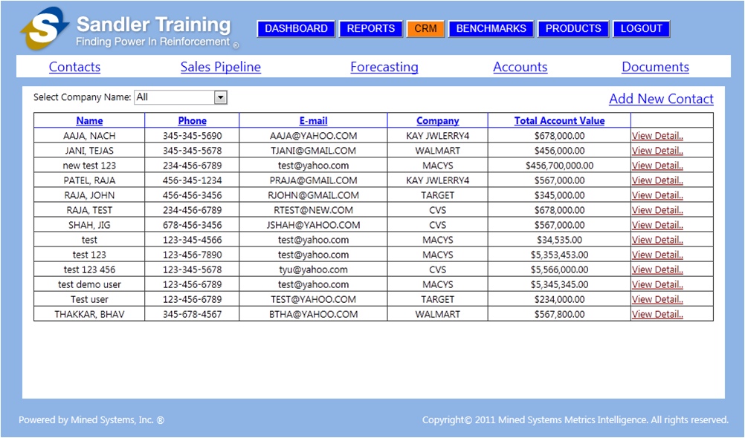

Figure 4‑1: Screen Shot – Existing CRM “Home” Screen

## Updated CRM “Accounts” Screen (aka CRM “Home” Screen)

This section describes the updates required to the existing CRM “Home” screen and the basic functionality of how the CRM module should function. This screen displays the “Accounts” component of the CRM Module, but this will be the default (aka “Home”) screen when a user clicks on the “CRM” button in the top line navigation.

The “arrow” and the “Note” on the screen shot in Figure 4‑2 below are providing explanation only and should NOT be included within the actual application.

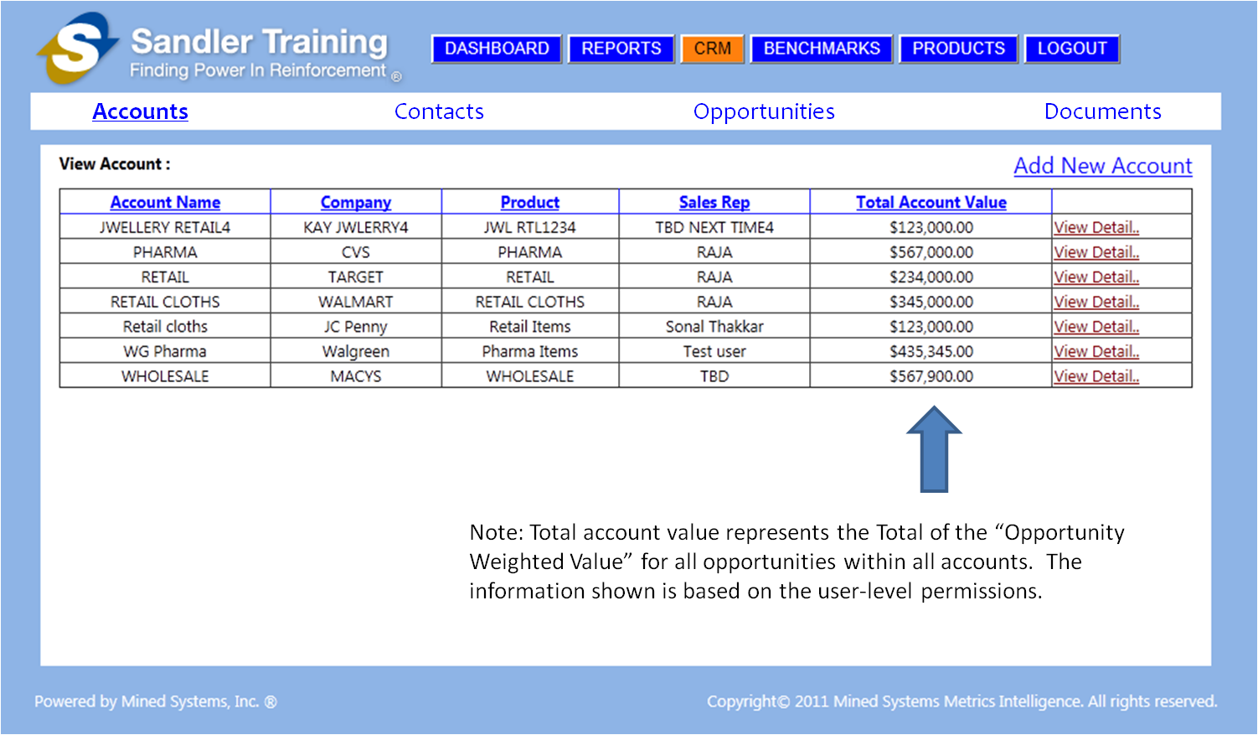

Figure 4‑2: Screen Shot – Updated CRM “Accounts” Summary Screen [aka – “Home” Screen]

The subsequent sub-sections describe the updates required and the role-based data access capabilities for this component of the CRM Module.

### Screen Changes

* CRM Module menu bar needs to be adjusted to ONLY have:
  + Accounts
  + Contacts
  + Opportunities [formerly called Sales Pipeline]
  + Documents
* CRM Module menu bar selections should NOT BE underlined
  + ONLY the item selected is **BOLD** and **UNDERLINED**

### Database Changes

* No database changes required for this screen

### Data Access by User-Level

* Franchise User Level
  + Cannot ADD a new account (e.g. the “Add New Account” link will not appear on the screen for this level user)
  + ALL accounts in the database for THIS FRANCHISE ONLY will be displayed in this screen
  + Can click “View Detail” for ALL accounts of THIS FRANCHISE ONLY displayed in this screen
* Franchise Owner Level
  + Can ADD a new account for THIS FRANCHISE ONLY (**NOTE**: This is the ONLY user that can create an Account)
  + ALL accounts in the database for THIS FRANCHISE ONLY will be displayed in this screen
  + Can click “View Detail” for ALL accounts for THIS FRANCHISE ONLY in this screen
* Coach Level
  + Cannot ADD a new account (e.g. the “Add New Account” link will not appear on the screen for this level user)
  + ALL accounts in the database for ALL FRANCHISES within the Coach’s REGION will be displayed in this screen
  + Can click “View Detail” for ALL accounts displayed in this screen
* Corporate Level
  + Cannot ADD a new account (e.g. the “Add New Account” link will not appear on the screen for this level user)
  + ALL accounts in the database for ALL FRANCHISES will be displayed in this screen
  + Can click “View Detail” for ALL accounts displayed in this

## Updated CRM “Add Account” Screen

When an authorized user clicks on the “Add New Account” function in the “Accounts” screen as seen in Figure 4‑3, the “Add Account” screen will be presented. The authorized user will be able to enter the appropriate information and add a new account.

The “arrow” and the “Note” on the screen shot in Figure 4‑3 below are providing explanation only and should NOT be included within the actual application.

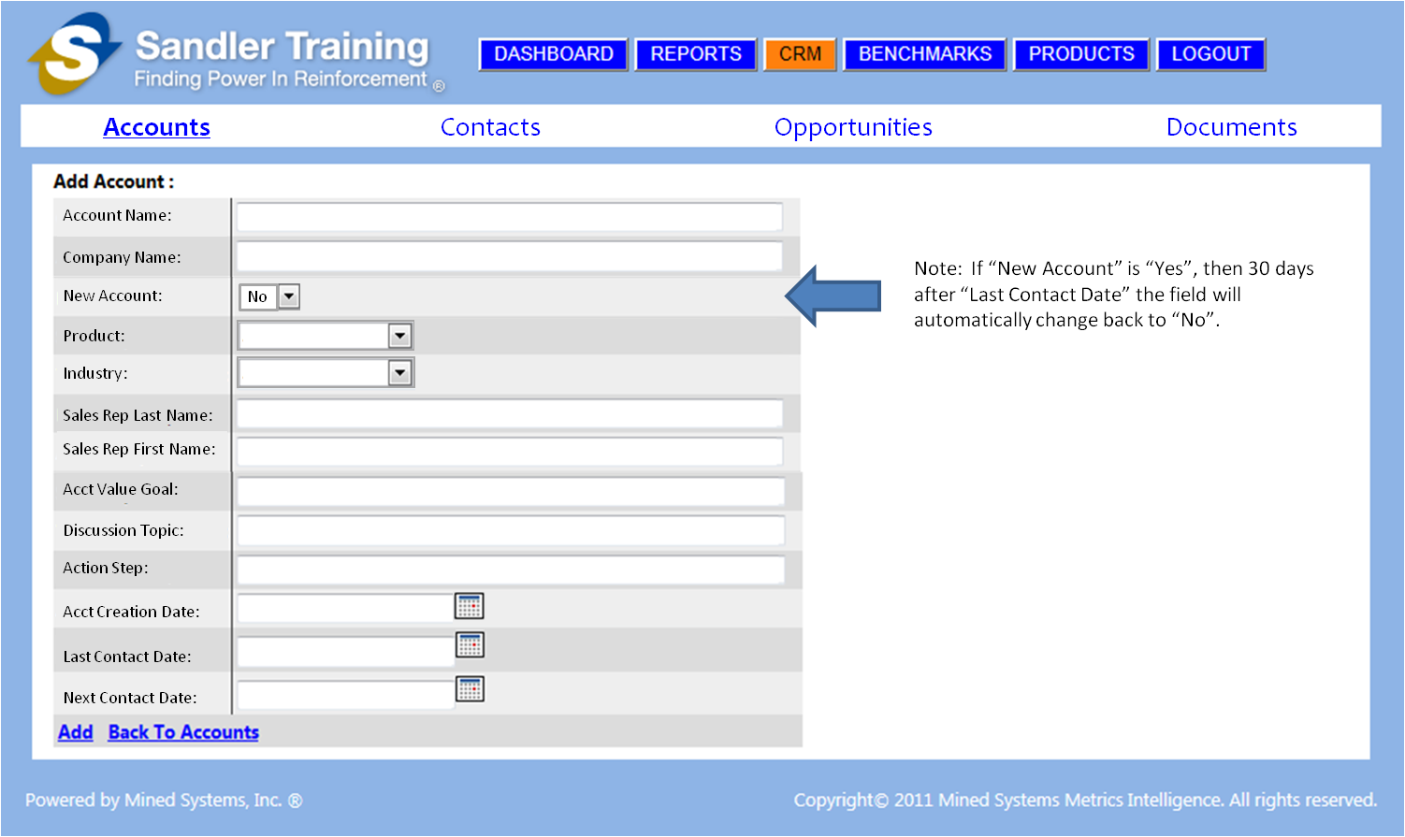

Figure ‑: Screen Shot – Add Account Screen

### Screen Changes

* CRM Module menu bar needs to be adjusted to ONLY have:
  + Accounts
  + Contacts
  + Opportunities [formerly called Sales Pipeline]
  + Documents
* CRM Module menu bar selections should NOT BE underlined
  + ONLY the item selected is **BOLD** and **UNDERLINED**
* “Account Name” field should be on the top line [instead of “Company Name”]
* “Company Name” field should be on the 2nd line [instead of the top line]
* “New Account” drop down field needs to be added on the 3rd line
* “Product” field needs to be updated on the 4th line to be a drop down box
* “Industry” field needs to be added on the 5th line as a drop down box
* “Sales Rep Last Name” field needs to be added on the 6th line
* “Sales Rep First Name” field needs to be added on the 7th line
* “Acct Value Goal” field needs to be added on the 8th line
* “Discussion Topic” field needs to be relocated to the 9th line
* “Action Step” field needs to be relocated to the 10th line
* “Acct Creation Date” field needs to be added on the 11th line and have a “date-pick” capability
* “Last Contact Date” field will be on the 12th line
* “Next Contact Date” field will be on the 13th line

### Database Changes

* “Account Name” field
  + This will be a data entry field
  + This will enable the user to enter the Account Name
* “Company Name” field
  + This will be a data entry field
  + This will enable the user to enter the Company Name
* “New Account” drop down field needs to be added
  + This field should be defaulted as “No” with the only choices being “Yes” or “No”
  + This field would be changed to “Yes” when a NEW account is being added
  + The automatic adjustments to this field will be further discussed in Sections 4.4.1 and 4.4.2 of the “Edit Account” screen functionality
  + The data in this field will be used in the “New Clients by Product Type” report
  + The data in this field will be used in the “New Client Quantity & Average Contract Price” report
* “Product” field needs to be updated to be a drop down box
  + The data in this field will be used in the “New Clients by Product Type” report
  + The drop down box needs to contain the following choices
    - Assessment
    - PC
    - Consulting
    - Training
    - Leadership
    - Coaching
* “Industry” drop down field needs to be added
  + The data in this field will be used in the “Class Headcount by Course & Industry” report
  + The data in this field will be used in the “Average Length of Time for Active Clients (by Industry)” report
  + The drop down box needs to contain the following choices
    - Professional Services
    - Service Industry
    - Manufacturing
    - Software
    - Consulting
* “Sales Rep Last Name” field needs to be added
  + This will be used to capture the last name of the sales rep that is handling this account
* “Sales Rep First Name” field needs to be added
  + This will be used to capture the first name of the sales rep that is handling this account
* “Acct Value Goal” field needs to be added
  + This will be used to capture the “Goal” of the expected value for the entire account
  + The data in this field will be used in the “Actual Dollars Booked and Comparison to Goal (by Month)” report
  + Within the account, there will be many different “Contacts” [e.g. staff] (as described in Section 4.5) along with many different opportunities (as described in Section 4.8)
* “Discussion Topic” field
  + This will be a data entry field
  + This will enable the user to enter any discussion topic(s) for this account
* “Action Step” field
  + This will be a data entry field
  + This will enable the user to enter any action step(s) for this account
* “Acct Creation Date” field needs to be added with a “date-pick” capability
  + This will be used to capture the date the account is actually created
  + The data in this field will be used in the “New Clients by Product Type (by Month)” report
  + The data in this field will be used in the “New Client Quantity & Average Contract Price (by Month)” report
  + The data in this field will be used in the “Average Length of Time for Active Clients (by Industry)” report
  + This date will not be changed once the account is created
* “Last Contact Date” field will have the “date-pick” capability
  + This field will be used to capture the last date that this account was contacted by the Sales Rep
* “Next Contact Date” field will be on the 13th line
  + This field will be used to capture the next date that this account is planned to be contacted by the Sales Rep

### Data Access by User-Level

* Franchise User Level
  + Does NOT have access to this screen
* Franchise Owner Level
  + Can ADD account record
  + This user is the ONLY user that can access the “Add Account” functionality
* Coach Level
  + Does NOT have access to this screen
* Corporate Level
  + Does NOT have access to this screen

## Updated CRM “Edit Account” Screen

When any user clicks on the “View Account” function in the “Accounts” screen as seen in Figure 4‑2, the “Edit Account” screen (shown in Figure 4‑4 below) will be presented. All users will be able to view the Account record presented on the screen. However, only an authorized user will be able to click “Edit” to edit the account record.

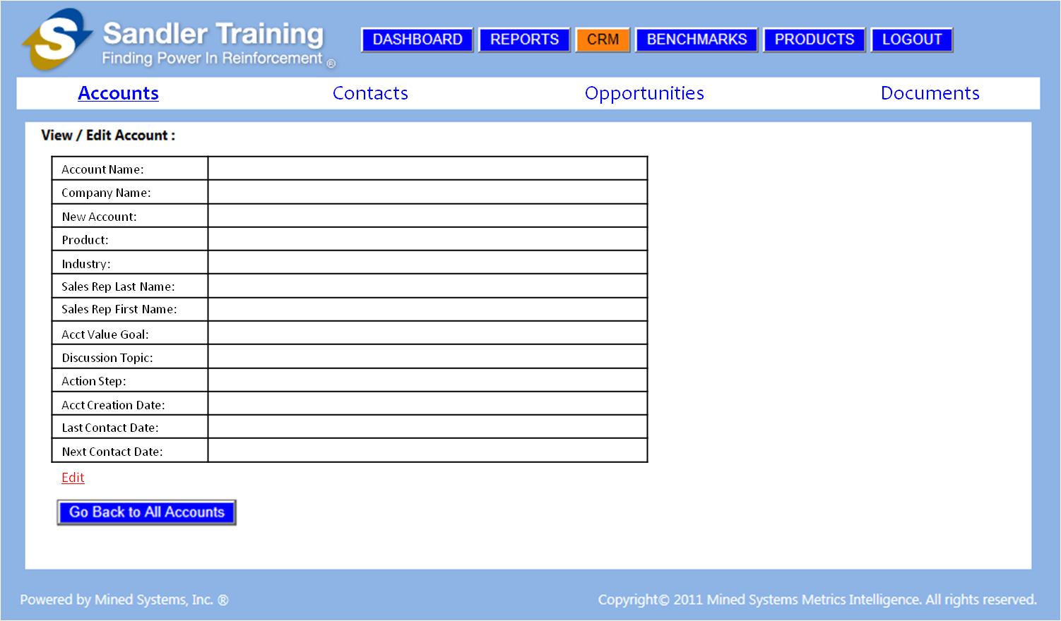

Figure ‑: Screen Shot – CRM Edit Account Screen

### Screen Changes

* CRM Module menu bar needs to be adjusted to ONLY have:
  + Accounts
  + Contacts
  + Opportunities [formerly called Sales Pipeline]
  + Documents
* CRM Module menu bar selections should NOT BE underlined
  + ONLY the item selected is **BOLD** and **UNDERLINED**
* “Account Name” field should be on the top line [instead of “Company Name”]
* “Company Name” field should be on the 2nd line [instead of the top line]
* “New Account” drop down field needs to be added on the 3rd line
* “Product” field needs to be updated on the 4th line to be a drop down box
* “Industry” field needs to be added on the 5th line as a drop down box
* “Sales Rep Last Name” field needs to be added on the 6th line
* “Sales Rep First Name” field needs to be added on the 7th line
* “Acct Value Goal” field needs to be added on the 8th line
* “Discussion Topic” field needs to be relocated to the 9th line
* “Action Step” field needs to be relocated to the 10th line
* “Acct Creation Date” field needs to be added on the 11th line and have a “date-pick” capability
* “Last Contact Date” field will be on the 12th line
* “Next Contact Date” field will be on the 13th line

### Database Changes

* The changes identified in Section 4.3.2 (for the Account Creation) are also applicable to the Account Editing

### Data Access by User-Level

* Franchise User Level
  + Can view the account record presented on this screen
  + Does NOT have access to edit the data on this screen [e.g. the “Edit” link will not be visible]
* Franchise Owner Level
  + Can EDIT the account record presented on this screen
  + This user is the ONLY user that can access the “Edit” functionality for the account record presented on this screen
* Coach Level
  + Can view the account record presented on this screen
  + Does NOT have access to edit the data on this screen [e.g. the “Edit” link will not be visible]
* Corporate Level
  + Can view the account record presented on this screen
  + Does NOT have access to edit the data on this screen [e.g. the “Edit” link will not be visible]

## Updated CRM “Contacts” Screen

This section describes the updates required to the existing CRM “Contacts” functionality of the CRM module. This screen displays the “Contacts” component of the CRM Module and will be displayed when a user clicks on the “Contacts” word in the CRM Module menu.

The major change with this screen is that the “Total Account Value” column has been removed since the “value” of an account, or an opportunity within an account, has no bearing on the specific “Contact” we are tracking.

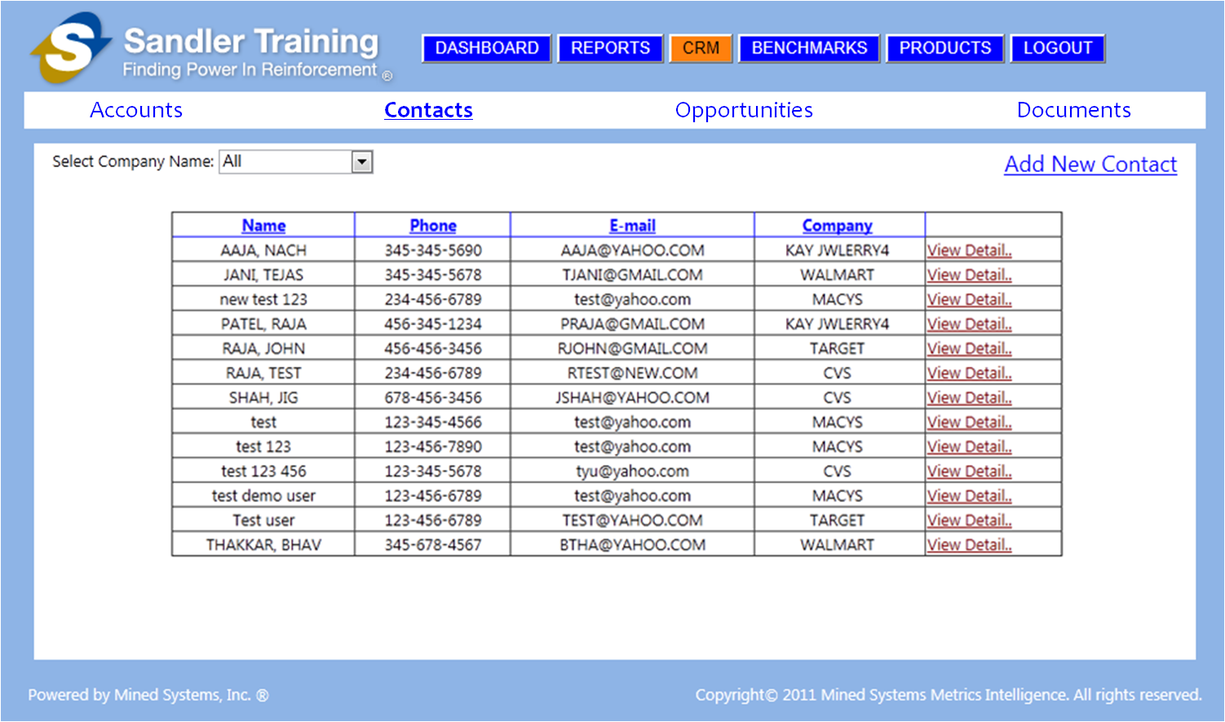

Figure 4‑5: Screen Shot – CRM Contacts Screen

### Screen Changes

* CRM Module menu bar needs to be adjusted to ONLY have:
  + Accounts
  + Contacts
  + Opportunities [formerly called Sales Pipeline]
  + Documents
* CRM Module menu bar selections should NOT BE underlined
  + ONLY the item selected is **BOLD** and **UNDERLINED**
* The “Total Account Value” column is being removed from the screen

### Database Changes

* No database changes required on this screen

### Data Access by User-Level

* Franchise User Level
  + Can ADD a new contact for THIS FRANCHISE ONLY
  + ALL contacts for ALL accounts in the database for THIS FRANCHISE ONLY that have been created by this Franchise User ONLY will be presented in this screen [for example – Franchise User #1 can see all contacts they have created, but they CANNOT see any contacts that Franchise User #2 has created]
  + Can click “View Detail” for ALL contacts for ALL accounts presented in this screen
* Franchise Owner Level
  + Can ADD a new contact for THIS FRANCHISE ONLY
  + ALL contacts for ALL contacts in the database for THIS FRANCHISE ONLY will be presented in this screen
  + Can click “View Detail” for ALL contacts presented in this screen
* Coach Level
  + Cannot ADD a new contact (e.g. clicking the “Add New Contact” function will not do anything)
  + ALL contacts for ALL accounts in the database for ALL FRANCHISES within the Coach’s REGION will be presented in this screen
  + Can click “View Detail” for ALL contacts for ALL accounts presented in this screen
* Corporate Level
  + Cannot ADD a new contact (e.g. clicking the “Add New Contact” function will not do anything)
  + ALL contacts within ALL accounts in the database for ALL FRANCHISES will be presented in this screen
  + Can click “View Detail” for ALL accounts presented in this screen

## Updated CRM “Add Contact” Screen

This section describes the updates required to the existing CRM “Add Contacts” screen which provides the ability for an authorized user to add a new contact within an “Account”.

The “arrow” and the “Note” on the screen shot in Figure 4‑6 below are providing explanation only and should NOT be included within the actual application.

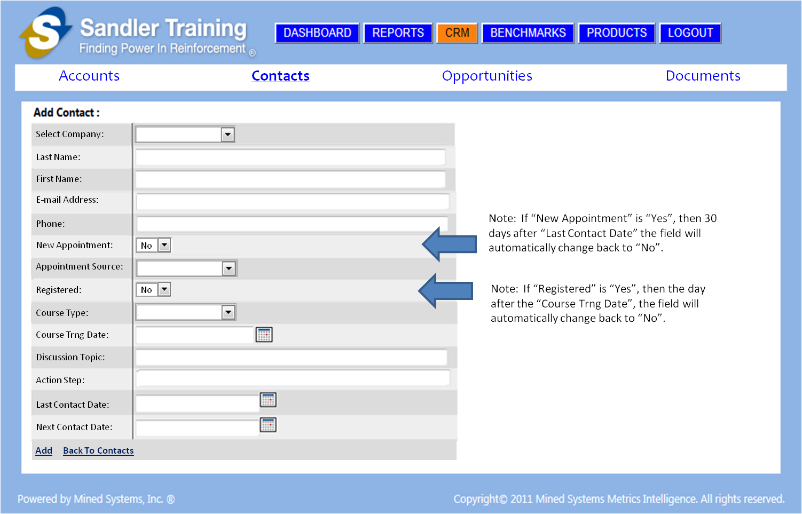

Figure ‑: Screen Shot – CRM Add Contact Screen

### Screen Changes

* CRM Module menu bar needs to be adjusted to ONLY have:
  + Accounts
  + Contacts
  + Opportunities [formerly called Sales Pipeline]
  + Documents
* CRM Module menu bar selections should NOT BE underlined
  + ONLY the item selected is **BOLD** and **UNDERLINED**

### Database Changes

### Data Access by User-Level

* Franchise User Level
* Franchise Owner Level
* Coach Level
* Corporate Level

## Updated CRM “Edit Contact” Screen

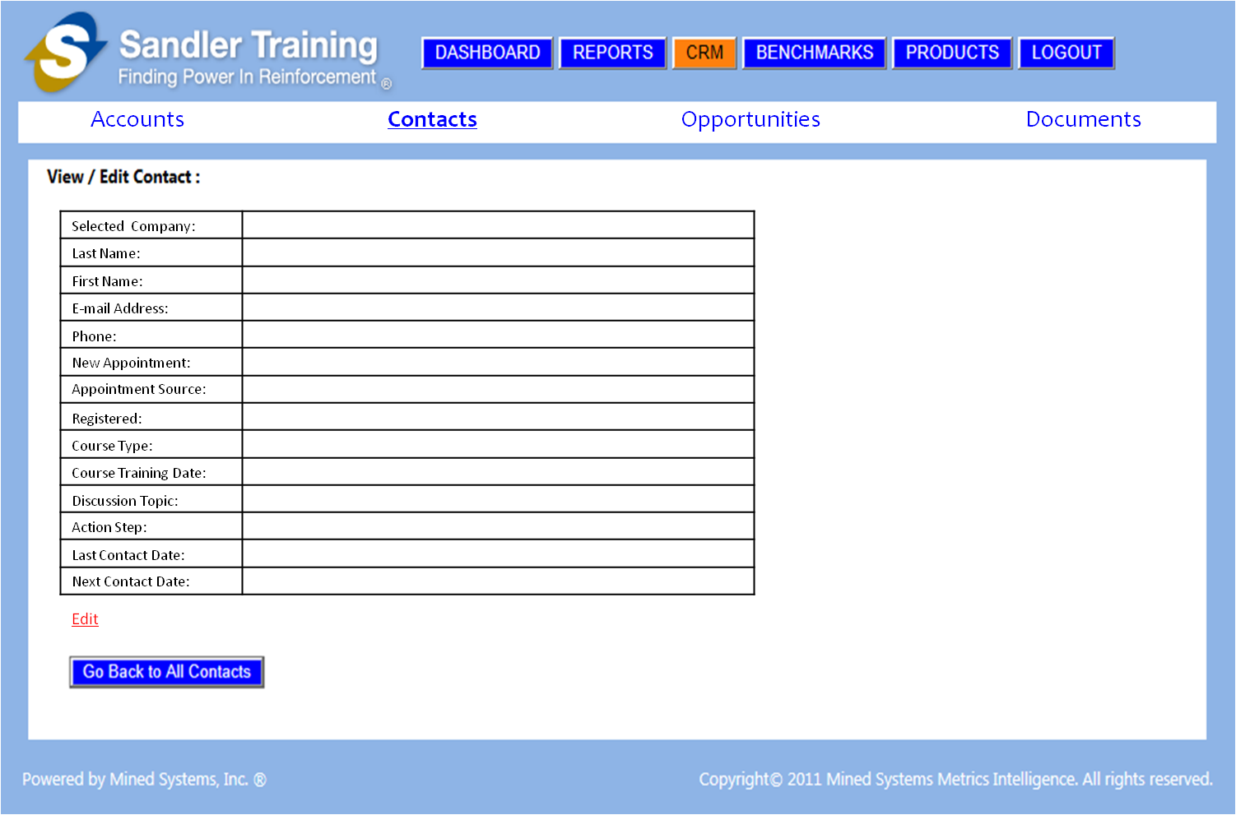

Figure ‑: Screen Shot – CRM Edit Contact Screen

### Screen Changes

* CRM Module menu bar needs to be adjusted to ONLY have:
  + Accounts
  + Contacts
  + Opportunities [formerly called Sales Pipeline]
  + Documents
* CRM Module menu bar selections should NOT BE underlined
  + ONLY the item selected is **BOLD** and **UNDERLINED**

### Database Changes

### Data Access by User-Level

* Franchise User Level
* Franchise Owner Level
* Coach Level
* Corporate Level

## Updated CRM “Opportunities” Screen

This section defines the updates required for the CRM Opportunities screen that was formerly called “Sales Pipeline”.

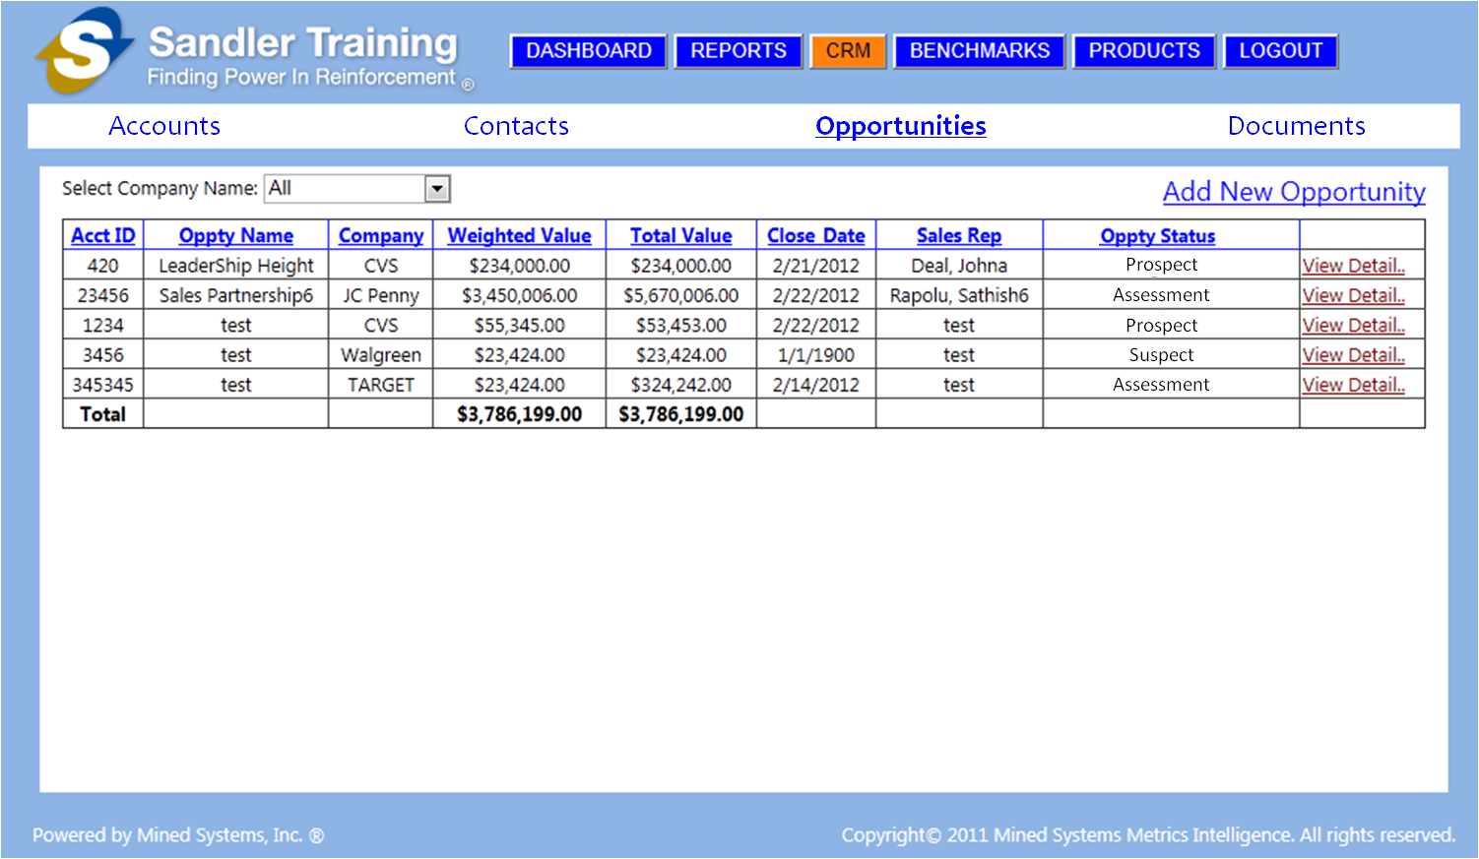

Figure 4‑8: Screen Shot – CRM Opportunities Screen

### Screen Changes

* CRM Module menu bar needs to be adjusted to ONLY have:
  + Accounts
  + Contacts
  + Opportunities [formerly called Sales Pipeline]
  + Documents
* CRM Module menu bar selections should NOT BE underlined
  + ONLY the item selected is **BOLD** and **UNDERLINED**

### Database Changes

### Data Access by User-Level

* Franchise User Level
* Franchise Owner Level
* Coach Level
* Corporate Level

## Updated CRM “Add Opportunity” Screen

The “arrow” and the “Note” on the screen shot in Figure 4‑9 below are providing explanation only and should NOT be included within the actual application.

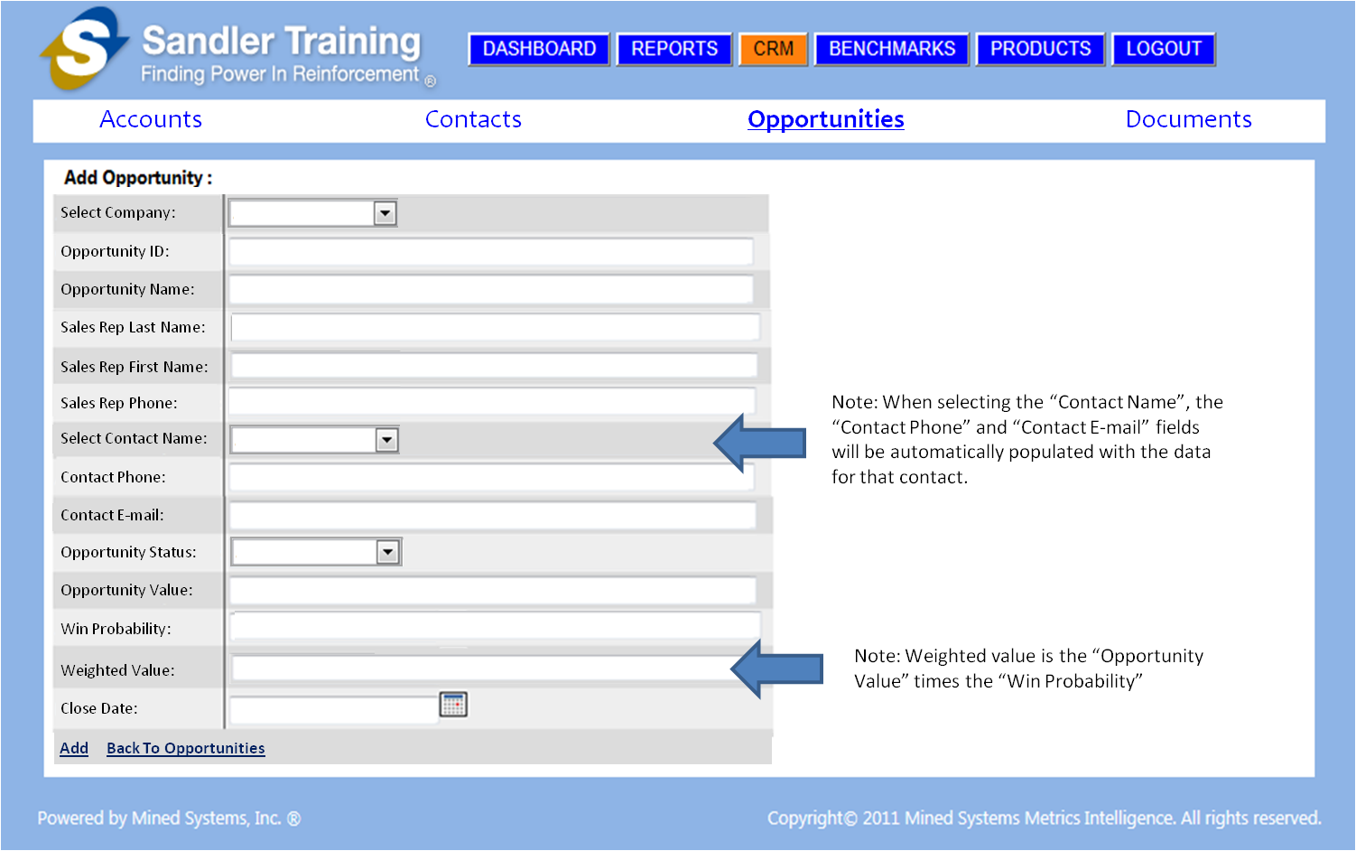

Figure ‑: Screen Shot – CRM Add Opportunity Screen

### Screen Changes

* CRM Module menu bar needs to be adjusted to ONLY have:
  + Accounts
  + Contacts
  + Opportunities [formerly called Sales Pipeline]
  + Documents
* CRM Module menu bar selections should NOT BE underlined
  + ONLY the item selected is **BOLD** and **UNDERLINED**

### Database Changes

### Data Access by User-Level

* Franchise User Level
* Franchise Owner Level
* Coach Level
* Corporate Level

## Updated CRM “Edit Opportunity” Screen

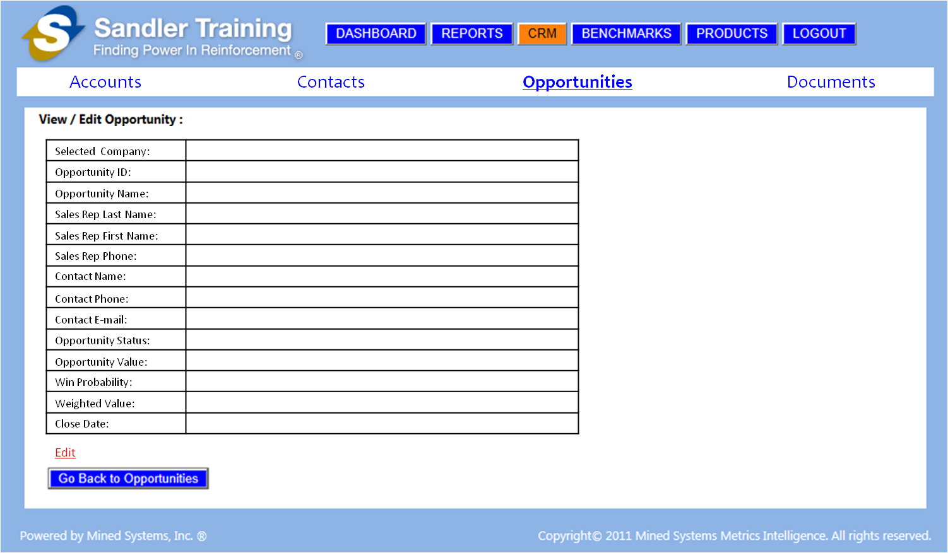

Figure ‑: Screen Shot – CRM Edit Opportunity Screen

### Screen Changes

* CRM Module menu bar needs to be adjusted to ONLY have:
  + Accounts
  + Contacts
  + Opportunities [formerly called Sales Pipeline]
  + Documents
* CRM Module menu bar selections should NOT BE underlined
  + ONLY the item selected is **BOLD** and **UNDERLINED**

### Database Changes

### Data Access by User-Level

* Franchise User Level
* Franchise Owner Level
* Coach Level
* Corporate Level

## CRM “Documents” Screen

This section defines the updates required for the CRM Documents screen as seen in

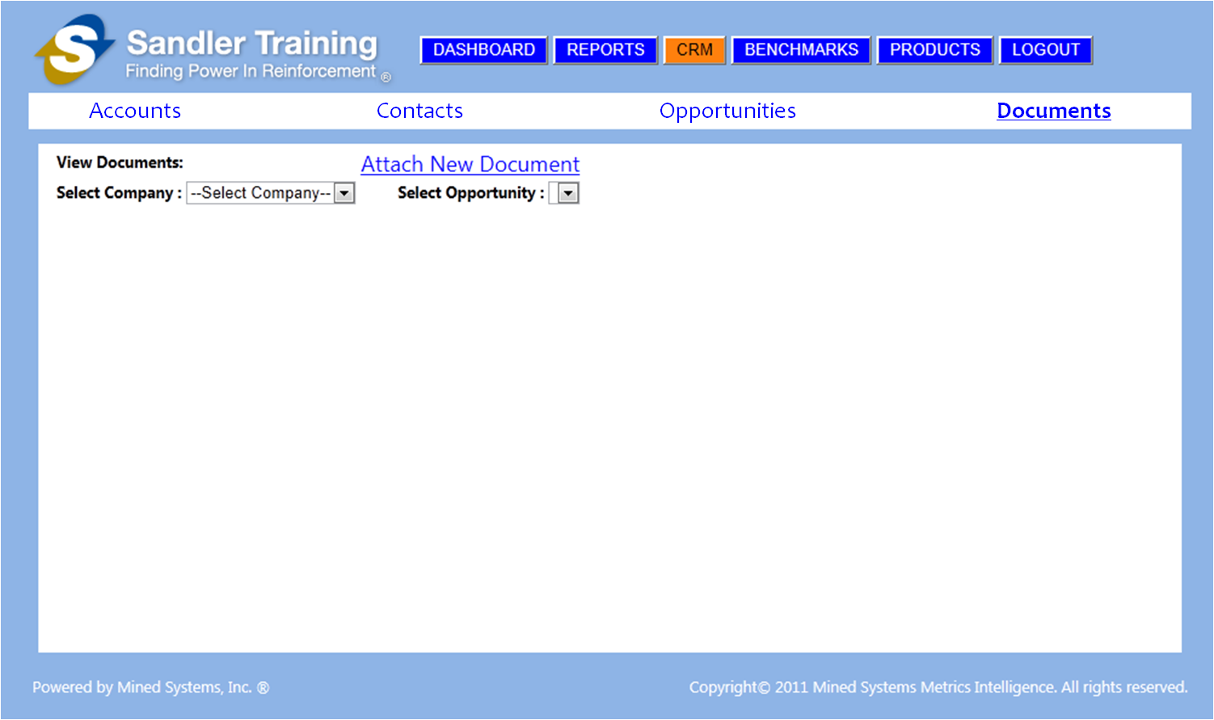

Figure 4‑11: Screen Shot – CRM Documents Screen

### Screen Changes

* CRM Module menu bar needs to be adjusted to ONLY have:
  + Accounts
  + Contacts
  + Opportunities [formerly called Sales Pipeline]
  + Documents
* CRM Module menu bar selections should NOT BE underlined
  + ONLY the item selected is **BOLD** and **UNDERLINED**

### Database Changes

### Data Access by User-Level

* Franchise User Level
* Franchise Owner Level
* Coach Level
* Corporate Level

## CRM “Attach New Document” Screen

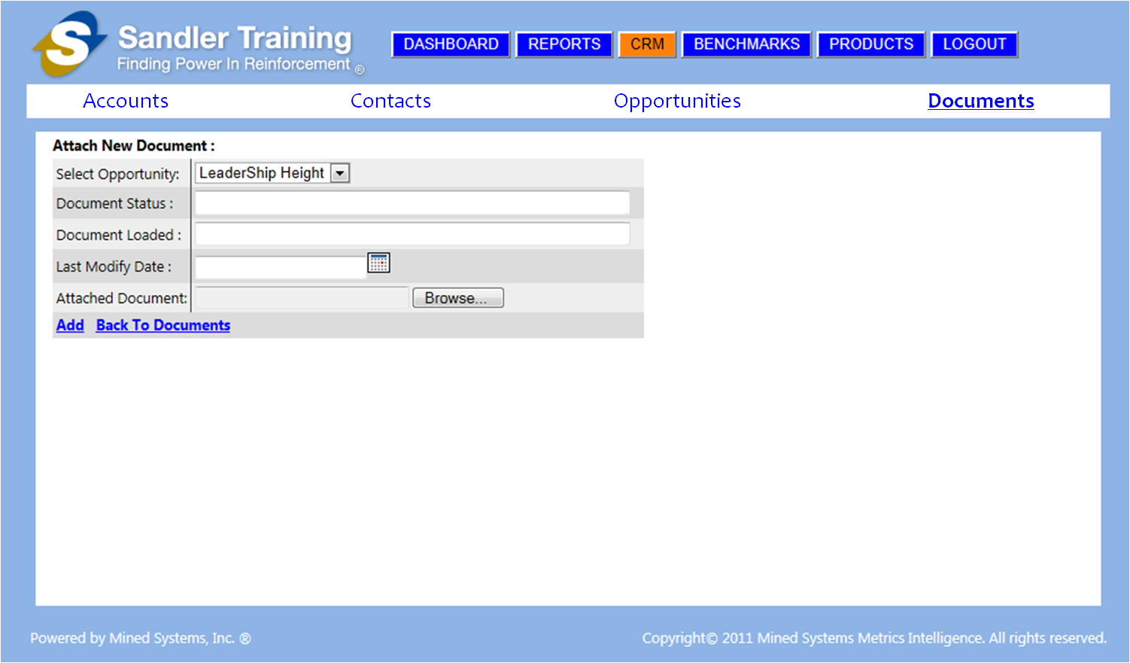

Figure ‑: Screen Shot – CRM Add Document Screen

### Screen Changes

* CRM Module menu bar needs to be adjusted to ONLY have:
  + Accounts
  + Contacts
  + Opportunities [formerly called Sales Pipeline]
  + Documents
* CRM Module menu bar selections should NOT BE underlined
  + ONLY the item selected is **BOLD** and **UNDERLINED**

### Database Changes

### Data Access by User-Level

* Franchise User Level
* Franchise Owner Level
* Coach Level
* Corporate Level

## CRM “Attach New Document with Details” Screen

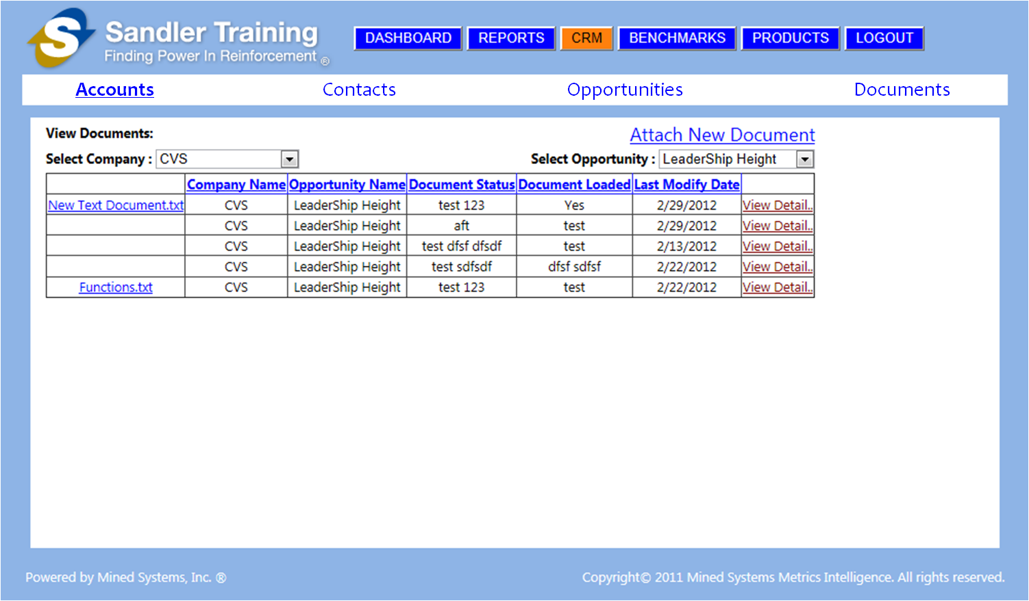

Figure ‑: Screen Shot – CRM Document Summary Screen

### Screen Changes

* CRM Module menu bar needs to be adjusted to ONLY have:
  + Accounts
  + Contacts
  + Opportunities [formerly called Sales Pipeline]
  + Documents
* CRM Module menu bar selections should NOT BE underlined
  + ONLY the item selected is **BOLD** and **UNDERLINED**

### Database Changes

### Data Access by User-Level

* Franchise User Level
* Franchise Owner Level
* Coach Level
* Corporate Level

## CRM “Edit Document” Screen

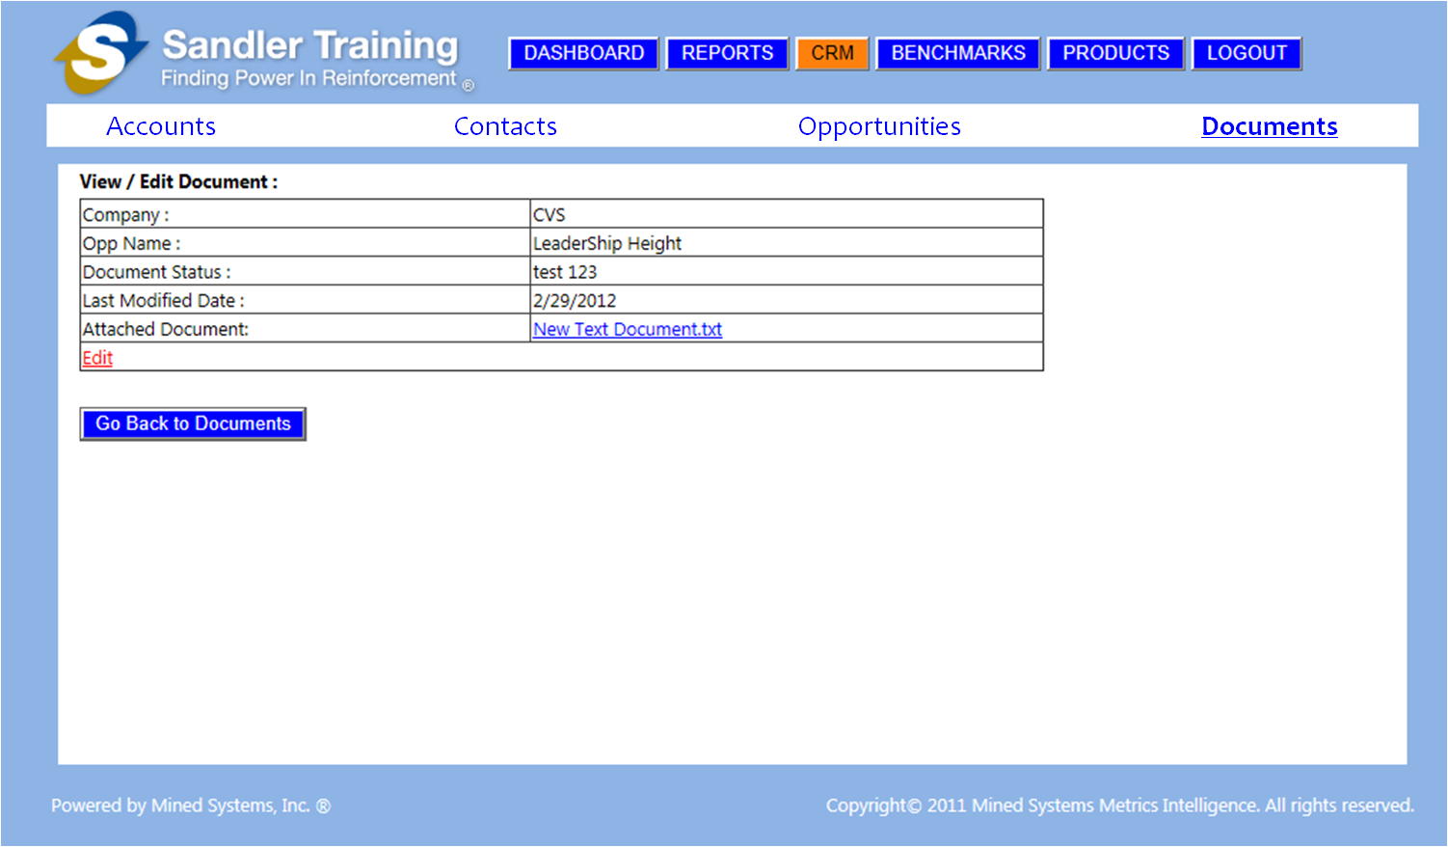

Figure ‑: Screen Shot – CRM Edit Document Screen

### Screen Changes

* CRM Module menu bar needs to be adjusted to ONLY have:
  + Accounts
  + Contacts
  + Opportunities [formerly called Sales Pipeline]
  + Documents
* CRM Module menu bar selections should NOT BE underlined
  + ONLY the item selected is **BOLD** and **UNDERLINED**

### Database Changes

### Data Access by User-Level

* Franchise User Level
* Franchise Owner Level
* Coach Level
* Corporate Level

# Sandler Reports

The only reports within this release of the Sandler application will be the 6 reports shown in Section 4.1 below. When the user clicks the “Reports” button, the drop down of the 6 reports will be shown as displayed in Section 4.1 below.

## Dashboard showing reports “drop down” selection

When the user selects the report [from the drop down] or by clicking on one of the 6 reports shown on the “Reports” screen, the “Full Screen” version of that report will be displayed to the user. The data being displayed in the report will be based upon the user-level of the individual who is logged in.

The actual data being displayed [based upon the user-level of the individual logged in] is described in each of the following subsections of this document.

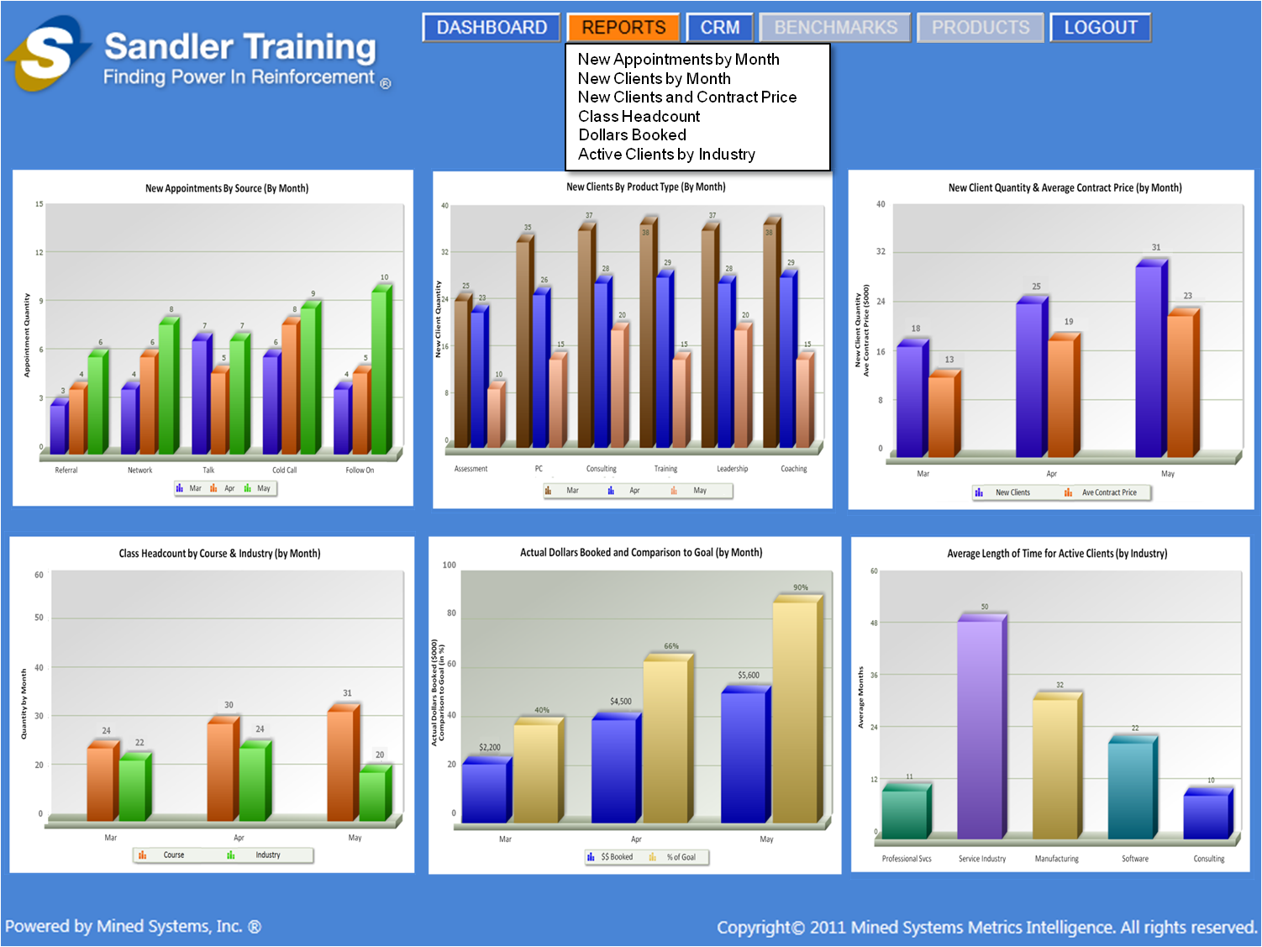

Figure 5‑1: Screen Shot – Dashboard Screen with Reports Dropdown

## New Appointments by Source (by Month)

This report has a summary and “drill down” capability to display the number of new appointments [broken down by Source] for any monthly period range desired. When selecting to run this report, the user will need to be presented with a dialog box to select the “Start Month” and “End Month” for the period [of months] to be shown in the report. The details of what data should be shown are based on the logged in user level as described in Sections 4.2.1.2 and 4.2.2.2 below.

### Summary Screen

The summary screen shows the summarization of data [within the Franchise, within the Region, or across all Regions] depending upon the user level. To drill down into a specific month, the user simply needs to click on the specific “month” bar within the chart for any of the source types. The drill down example in this document [shown in Section 4.2.2] is for the month of March.

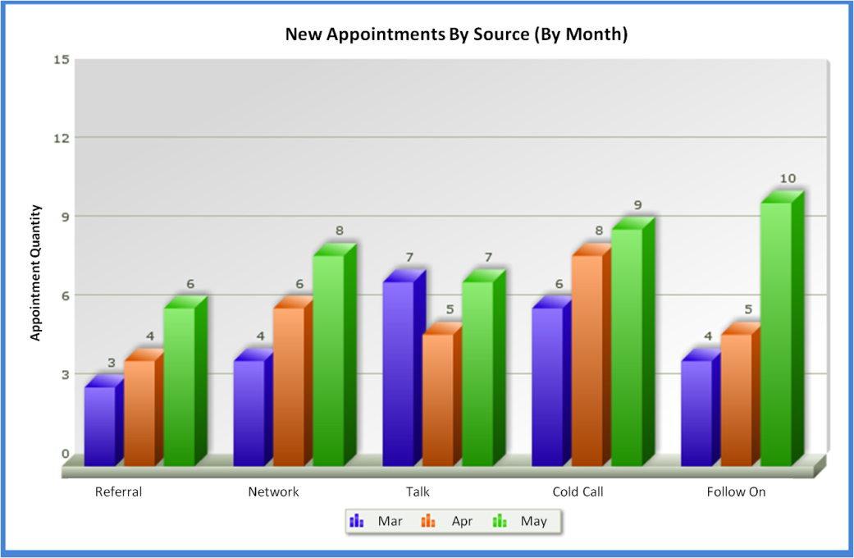

Figure 5‑2: Screen Shot - New Appointments by Source (by Month)

#### Data required

* A “New Appointment” is a scheduled meeting within “Contact” that is entered into the “Contacts” section of the CRM Module of the existing application
* **NEW “Contacts” CRM MODULE FIELDS NEED TO BE ADDED**
  + Check box titled “New” to indicate this is a “New Appointment”
    - This check box would only stay “checked” as new for 30 days from the “Last Contact Date” field
    - On Day 31 after the “Last Contact Date”, the check mark would be removed automatically
  + Add an “Appointment Source” as a “drop down” selection in the “Add Contact” screen that contains the following 5 types:
    - Referral
    - Network
    - Talk
    - Cold Call
    - Follow On
* The flag for the “New Appointment” would be from the new check box field entitled “New Appointment”
* User Total – Actual new appointments [by source], by user, within each Franchise [by month]
* Franchise Total – Summary of new appointments [by source] for all users within each Franchise [by month]
* Region Total – Summary of new appointments [by source] for all users within each Franchise, within the Region [by month]
* Corporate Total – Summary of new appointments [by source] for all users within each Franchise, within each Region [by month]

#### Data Display by User-Level

* Summary of new appointments [by source], by month, as follows:
  + Franchise User
    - Summary of the Franchise User’s new appointments [by source], by month
  + Franchise Owner
    - Summary of all new appointments [by source] by all of the Franchise Users within the Franchise [by month]
  + Coach
    - Summary of all new appointments [by source] for all of the Franchises within the Region [by month]
  + Corporate
    - Summary of all new appointments [by source] for all of the Regions [by month]

### Drill Down Screen

The drill down example shown here is for the month of March. This chart shows the total new appointments for that month as a percentage, by Source.

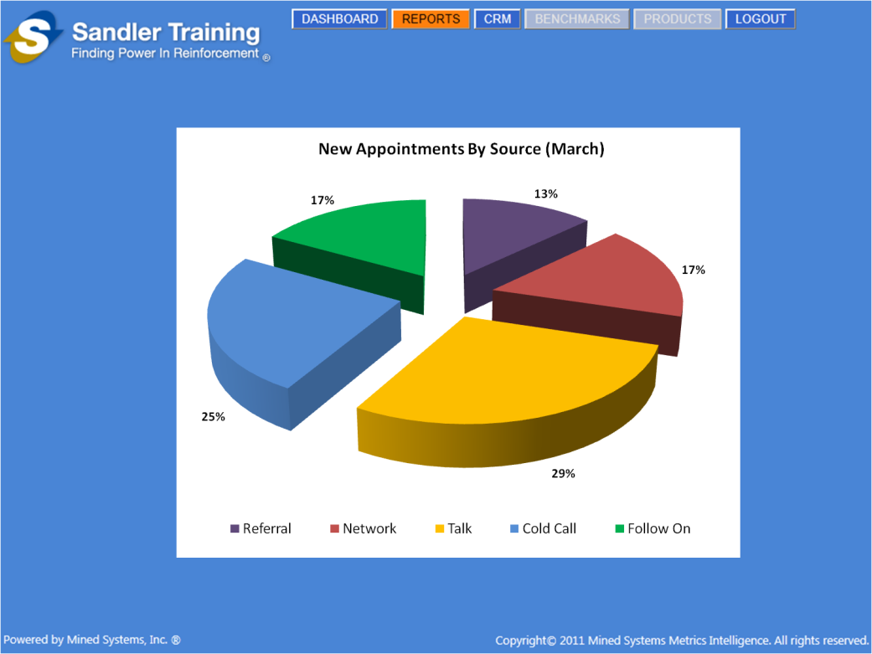

Figure 5‑3: Screen Shot – New Appoints by Source Drill Down

#### Data required

* Appointment source as one of the following 5 types:
  + Referral
  + Network
  + Talk
  + Cold Call
  + Follow On
* The flag for the “New Appointment” would be from the new check box field entitled “New Appointment”
* User Total – Actual new appointments [by source], by user, within each Franchise [by month]
* Franchise Total – Summary of new appointments [by source] for all users within each Franchise [by month]
* Region Total – Summary of new appointments [by source] for all users within each Franchise, within the Region [by month]
* Corporate Total – Summary of new appointments [by source] for all users within each Franchise, within each Region [by month]

#### Data Display by User-Level

* Summary of new appointments [by source] for a specific month, as follows:
  + Franchise User
    - Summary of the Franchise User’s new appointments [by source] for a specific month
  + Franchise Owner
    - Summary of all new appointments [by source] by all of the Franchise Users within the Franchise for a specific month
  + Coach
    - Summary of all new appointments [by source] for all of the Franchises within the Region for a specific month
  + Corporate
    - Summary of all new appointments [by source] for all of the Regions for a specific month

## New Clients by Product Type (by Month)

This report has a summary and “drill down” capability to display the number of new clients [broken down by Product Type] for any monthly period range desired. When selecting to run this report, the user will need to be presented with a dialog box to select the “Start Month” and “End Month” for the period [of months] to be shown in the report. The details of what data should be shown are based on the logged in user level as described in Sections 4.3.1.2 and 4.3.2.2 below.

### Summary Screen

The summary screen shows the summarization of data [within the Franchise, within the Region, or across all Regions] depending upon the user level. To drill down into a specific month, the user simply needs to click on the specific “month” bar within the chart for any of the product types. The drill down example in this document [shown in Section 4.3.2] is for the month of May.

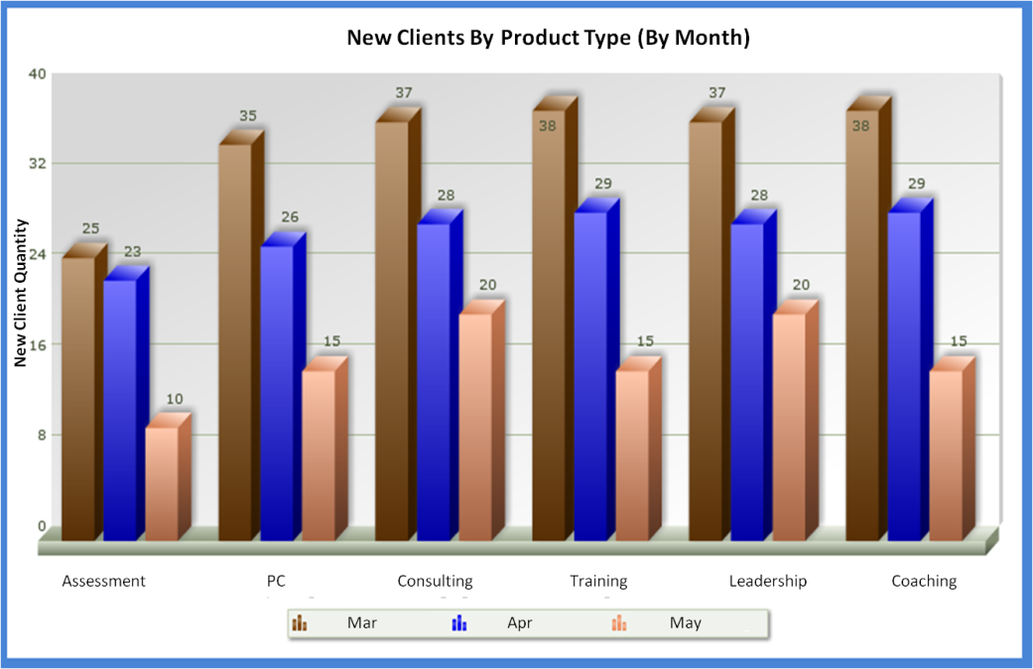

Figure 5‑4: Screen Shot – New Clients by Product Type (by Month)

#### Data required

* “New Client” is the same as “New Account”
* **NEW “Accounts” CRM MODULE FIELDS NEED TO BE ADDED/ADJUSTED**
  + Check box titled “New” to indicate this is a “New Account”
    - This check box would only stay “checked” as new for 30 days from the “Last Contact Date” field
    - On Day 31 after the “Last Contact Date”, the check mark would be removed automatically
  + Existing “Product” field needs to be changed to a “drop down” selection in the “Add Account” screen that contains the following 6 types:
    - Assessment
    - PC
    - Consulting
    - Training
    - Leadership
    - Coaching
* The flag for the “New Account” would be from the new check box field entitled “New Account”
* User Total – Actual new clients [by Product Type], by user, within each Franchise [by month]
* Franchise Total – Summary of new clients [by Product Type] for all users within each Franchise [by month]
* Region Total – Summary of new client[by Product Type] for all users within each Franchise, within the Region [by month]
* Corporate Total – Summary of new clients [by Product Type] for all users within each Franchise, within each Region [by month]

#### Data Display by User-Level

* Summary of new clients [by Product Type], by month, as follows:
  + Franchise User
    - Summary of the Franchise User’s new clients [by Product Type], by month
  + Franchise Owner
    - Summary of all new clients [by Product Type] by all of the Franchise Users within the Franchise [by month]
  + Coach
    - Summary of all new clients [by Product Type] for all of the Franchises within the Region [by month]
  + Corporate
    - Summary of all new clients [by Product Type] for all of the Regions [by month]

### Drill Down Screen

The drill down example shown here is for the month of May. This chart shows the total new clients for that month as a percentage, by Product Type.

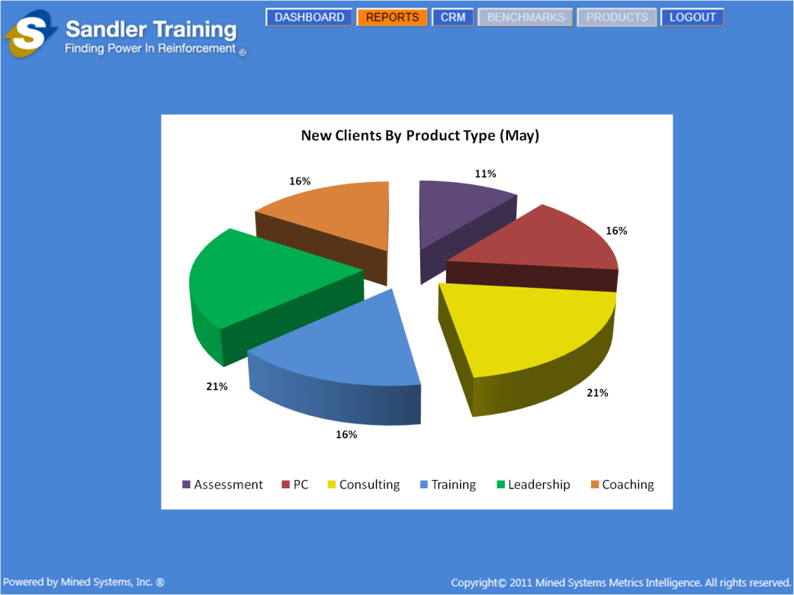

Figure 5‑5: Screen Shot – New Clients by Product Type, Drill Down

#### Data required

* New client as one of the following 6 Product Types:
  + Assessment
  + PC
  + Consulting
  + Training
  + Leadership
  + Coaching
* New client is the same as New Account
* User Total – Actual new clients [by Product Type], by user, within each Franchise [by month]
* Franchise Total – Summary of new clients [by Product Type] for all users within each Franchise [by month]
* Region Total – Summary of new clients [by Product Type] for all users within each Franchise, within the Region [by month]
* Corporate Total – Summary of new clients [by Product Type] for all users within each Franchise, within each Region [by month]

#### Data Display by User-Level

* Summary of new Clients [by Product Type] for a specific month, as follows:
  + Franchise User
    - Summary of the Franchise User’s new clients [by Product Type] for a specific month
  + Franchise Owner
    - Summary of all new clients [by Product Type] by all of the Franchise Users within the Franchise for a specific month
  + Coach
    - Summary of all new clients [by Product Type] for all of the Franchises within the Region for a specific month
  + Corporate
    - Summary of all new clients [by Product Type] for all of the Regions for a specific month

## New Client Quantity and Average Contract Price (by Month)

This report has a summary and “drill down” capability to display the number of new clients and the average contract price [summarized for all Product Types except Assessments] for any monthly period range desired. When selecting to run this report, the user will need to be presented with a dialog box to select the “Start Month” and “End Month” for the period [of months] to be shown in the report. The details of what data should be shown are based on the logged in user level as described in Sections 4.4.1.2 and 4.4.2.2 below.

### Summary Screen

The summary screen shows the summarization of data [within the Franchise, within the Region, or across all Regions] depending upon the user level. To drill down into a specific month, the user simply needs to click on the specific “month” bar [of New Clients or Contract Price] within the chart. The drill down example in this document [shown in Section 4.4.2] is for the month of April.

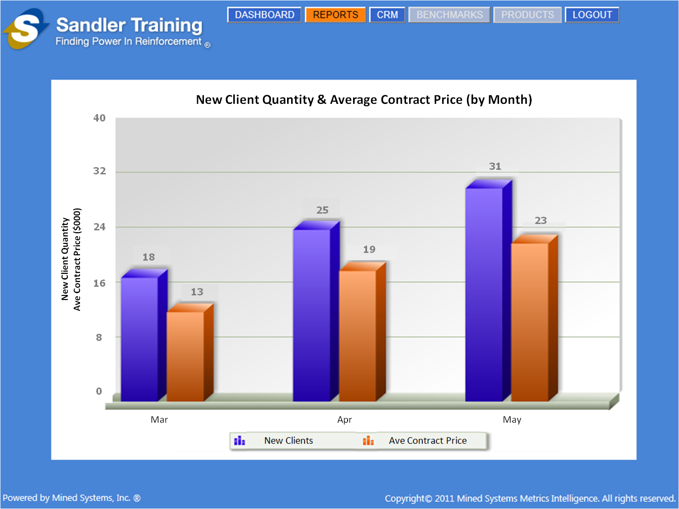

Figure 5‑6: Screen Shot – New Client Quantity & Average Contract Price (by Month)

#### Data required

* New clients as one of the following 5 Product Types [since we are NOT including Assessments]:
  + PC
  + Consulting
  + Training
  + Leadership
  + Coaching
* New client is the same as New Account
* Use the value of “Total Account Value” to determine the “Average Contract Price” for those clients noted as “New” with the new “checkbox” field that will be added
* User Total – Summary of new clients for all Product Types [except Assessments], by user, within each Franchise [by month]
* Franchise Total – Summary of new clients for all Product Types [except Assessments] for all users within each Franchise [by month]
* Region Total – Summary of new clients for all Product Types [except Assessments] for all users within each Franchise, within the Region [by month]
* Corporate Total – Summary of new clients for all Product Types [except Assessments] for all users within each Franchise, within each Region [by month]
* Average contract price for new clients as one of the following 5 Product Types [since we are NOT including Assessments]:
  + PC
  + Consulting
  + Training
  + Leadership
  + Coaching
* User Total – Summary of average contract price for all Product Types [except Assessments] for the user’s new clients, by user, within each Franchise [by month]
* Franchise Total – Summary of the average contract price for all Product Types [except Assessments] for all new clients for all users within each Franchise [by month]
* Region Total – Summary of the average contract price for all Product Types [except Assessments] for all new clients for all users within each Franchise, within the Region [by month]
* Corporate Total – Summary of the average contract price for all Product Types [except Assessments] for all new clients for all users within each Franchise, within each Region [by month]

#### Data Display by User-Level

* Summary of new clients for all Product Types [except Assessments], by month, as follows:
  + Franchise User
    - Summary of the Franchise User’s new clients for all Product Types [except Assessments], by month
  + Franchise Owner
    - Summary of all new clients for all Product Types [except Assessments] by all of the Franchise Users within the Franchise [by month]
  + Coach
    - Summary of all new clients for all Product Types [except Assessments] for all of the Franchises within the Region [by month]
  + Corporate
    - Summary of all new clients for all Product Types [except Assessments] for all of the Regions [by month]
* Summary of the average contract price for the new clients for all Product Types [except Assessments], by month, as follows:
  + Franchise User
    - Summary of the Franchise User’s average contract price for their new clients for all Product Types [except Assessments], by month
  + Franchise Owner
    - Summary of all average contract prices for all new clients for all Product Types [except Assessments] by all of the Franchise Users within the Franchise [by month]
  + Coach
    - Summary of all average contract prices for all new clients for all Product Types [except Assessments] for all of the Franchises within the Region [by month]
  + Corporate
    - Summary of all average contract prices for all new clients for all Product Types [except Assessments] for all of the Regions [by month]

### Drill Down Screen

The drill down example shown here is for the month of April. This chart shows the total quantity of new clients for that month [by Product Type] as well as the average contract price for those new clients [by Product Type].

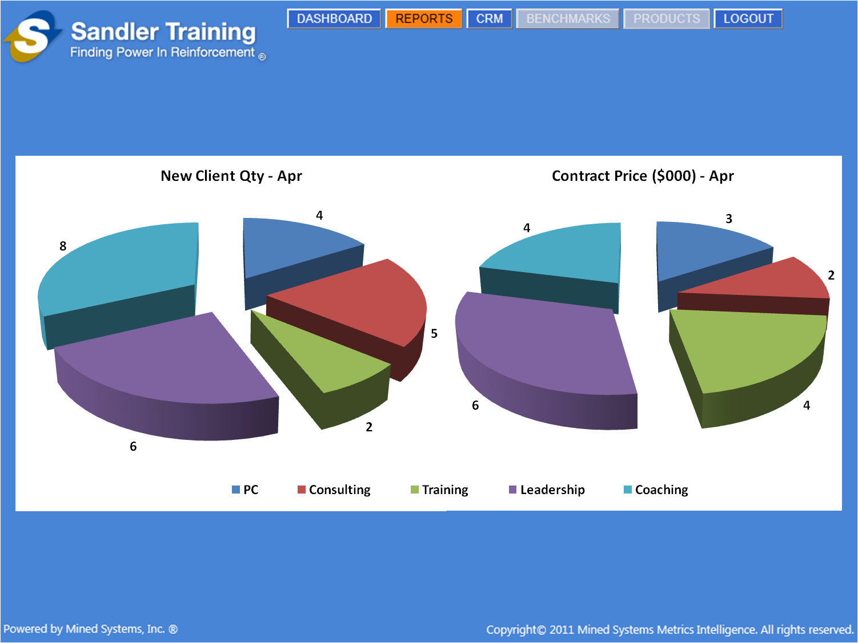

Figure 5‑7: Screen Shot – New Client Quantity & Average Contract Price Drill Down

#### Data required

* New clients as one of the following 5 Product Types [since we are NOT including Assessments]:
  + PC
  + Consulting
  + Training
  + Leadership
  + Coaching
* New client is the same as New Account
* User Total – Actual new client quantity for all Product Types [except Assessments], by user, within each Franchise [by month]
* Franchise Total – Summary of new client quantity for all Product Types [except Assessments] for all users within each Franchise [by month]
* Region Total – Summary of new client quantity for all Product Types [except Assessments] for all users within each Franchise, within the Region [by month]
* Corporate Total – Summary of new client quantity for all Product Types [except Assessments] for all users within each Franchise, within each Region [by month]
* Average contract price for new clients as one of the following 5 Product Types [since we are NOT including Assessments]:
  + PC
  + Consulting
  + Training
  + Leadership
  + Coaching
* User Total – Summary of average contract price for all Product Types [except Assessments] for the user’s new clients, by user, within each Franchise [by month]
* Franchise Total – Summary of the average contract price for all Product Types [except Assessments] for all new clients for all users within each Franchise [by month]
* Region Total – Summary of the average contract price for all Product Types [except Assessments] for all new clients for all users within each Franchise, within the Region [by month]
* Corporate Total – Summary of the average contract price for all Product Types [except Assessments] for all new clients for all users within each Franchise, within each Region [by month]

#### Data Display by User-Level

* Summary of new client quantity for all Product Types [except Assessments] for a specific month, as follows:
  + Franchise User
    - Summary of the Franchise User’s new client quantity for all Product Types [except Assessments] for a specific month
  + Franchise Owner
    - Summary of all new client quantity for all Product Types [except Assessments] by all of the Franchise Users within the Franchise for a specific month
  + Coach
    - Summary of all new client quantity for all Product Types [except Assessments] for all of the Franchises within the Region for a specific month
  + Corporate
    - Summary of all new client quantity for all Product Types [except Assessments] for all of the Regions for a specific month
* Summary of average contract price for all new clients for all Product Types [except Assessments] for a specific month, as follows:
  + Franchise User
    - Summary of the Franchise User’s average contract price for all new clients for all Product Types [except Assessments] for a specific month
  + Franchise Owner
    - Summary of the average contract price for all new clients for all Product Types [except Assessments] by all of the Franchise Users within the Franchise for a specific month
  + Coach
    - Summary of the average contract price for all new clients for all Product Types [except Assessments] for all of the Franchises within the Region for a specific month
  + Corporate
    - Summary of the average contract price for all new clients for all Product Types [except Assessments] for all of the Regions for a specific month

## Class Headcount by Course and Industry (by Month)

This report has a summary and “drill down” capability to display the class headcount by course and industry for any monthly period range desired. When selecting to run this report, the user will need to be presented with a dialog box to select the “Start Month” and “End Month” for the period [of months] to be shown in the report. The details of what data should be shown are based on the logged in user level as described in Sections 4.5.1.2 and 4.5.2.2 below.

### Summary Screen

The summary screen shows the summarization of data [within the Franchise, within the Region, or across all Regions] depending upon the user level. To drill down into a specific month, the user simply needs to click on the specific “month” bar [of Course or Industry] within the chart. The drill down example in this document [shown in Section 4.5.2] is for the month of May.

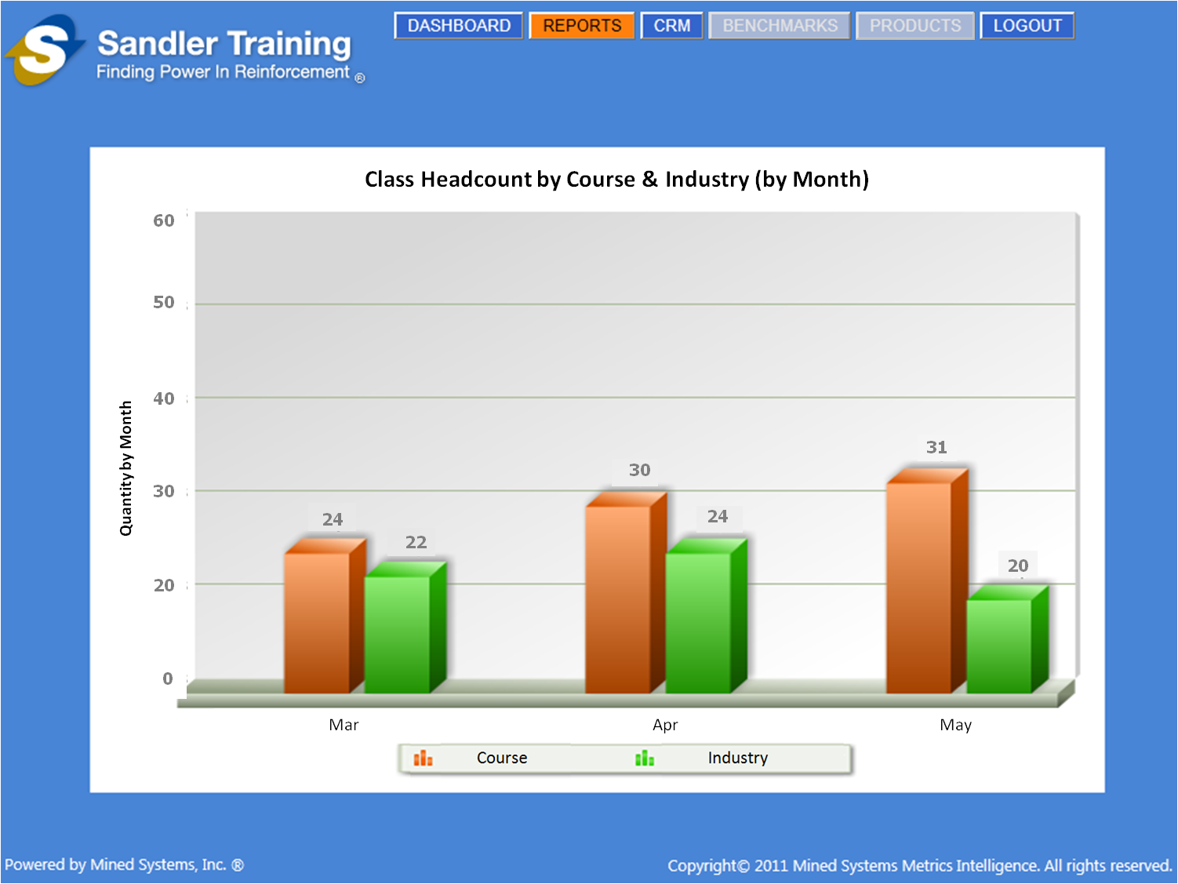

Figure 5‑8: Screen Shot – Class Headcount by Course & Industry (by Month)

#### Data required

* **NEW “Contacts” CRM MODULE FIELDS NEED TO BE ADDED**
  + Create a “check box” field titled “Registered”
    - This will indicate that the “Contact” is registered for a class
  + Add a “Course Type” field as a “drop down” selection in the “Add Contact” screen that contains the following 4 course types:
    - PC
    - Foundations
    - Management
    - Bootcamp
  + Create a date field titled “Course Training Date”
    - This will be used to indicate the date for the training in one of the selected “courses”
  + Add a “Industry Type” field as a “drop down” selection in the “Add Contact” screen that contains the following Industry Types:
    - Professional Services
    - Service Industry
    - Manufacturing
    - Software
    - Consulting
  + Create a date field titled “Industry Training Date”
    - This will be used to indicate the date for the training in one of the selected “industries”
* Summary of headcount of students registered for training class for the following course types:
  + PC
  + Foundations
  + Management
  + Bootcamp
* User Total – Summary of students for all Course Types, registered by a user, within each Franchise [by month]
* Franchise Total – Summary of students for all Course Types registered by any of the users within each Franchise [by month]
* Region Total – Summary of students for all Course Types registered by any of the users within each Franchise, within the Region [by month]
* Corporate Total – Summary of students for all Course Types registered by any of the users within each Franchise, within each Region [by month]
* Summary of headcount of students registered for training class for the following industry types:
  + Professional Services
  + Service Industry
  + Manufacturing
  + Software
  + Consulting
* User Total – Summary of students for all Industry Types, registered by a user, within each Franchise [by month]
* Franchise Total – Summary of students for all Industry Types registered by any of the users within each Franchise [by month]
* Region Total – Summary of students for all Industry Types registered by any of the users within each Franchise, within the Region [by month]
* Corporate Total – Summary of students for all Industry Types registered by any of the users within each Franchise, within each Region [by month]

#### Data Display by User-Level

* Summary of students for all Course Types registered, by month, as follows:
  + Franchise User
    - Summary of the students for all Course Types registered by a Franchise User, by month
  + Franchise Owner
    - Summary of the students for all Course Types registered by any of the Franchise Users within the Franchise [by month]
  + Coach
    - Summary of the students for all Course Types registered by any of the Franchise Users within the Franchises within the Region [by month]
  + Corporate
    - Summary of the students for all Course Types registered by any of the Franchise Users within the Franchises for all of the Regions [by month]
* Summary of students for all Industry Types registered, by month, as follows:
  + Franchise User
    - Summary of the students for all Industry Types registered by a Franchise User, by month
  + Franchise Owner
    - Summary of the students for all Industry Types registered by any of the Franchise Users within the Franchise [by month]
  + Coach
    - Summary of the students for all Industry Types registered by any of the Franchise Users within the Franchises within the Region [by month]
  + Corporate
    - Summary of the students for all Industry Types registered by any of the Franchise Users within the Franchises for all of the Regions [by month]

### Drill Down Screen

The drill down example shown here is for the month of May. This chart shows the total quantity of students registered for that month [by Course Type] as well as the total quantity of students registered for that month [by Industry Type].

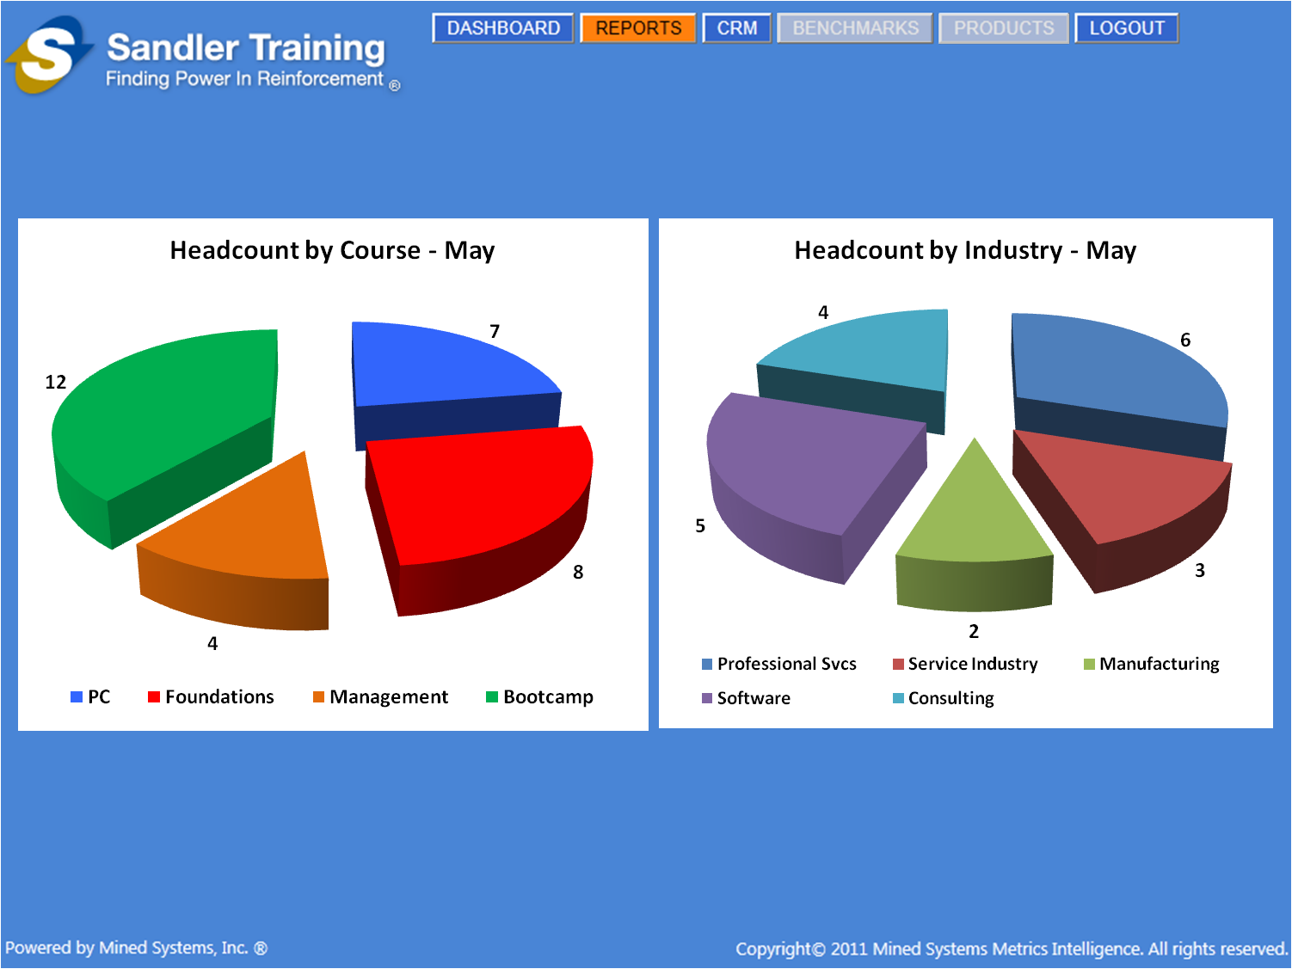

Figure 5‑9: Screen Shot – Headcount by Course & Industry Drill Down

#### Data required

* Summary of headcount of students registered for training class for the following course types:
  + PC
  + Foundations
  + Management
  + Bootcamp
* User Total – Summary of students for all Course Types, registered by a user, within each Franchise for a specific month
* Franchise Total – Summary of students for all Course Types registered by any of the users within each Franchise for a specific month
* Region Total – Summary of students for all Course Types registered by any of the users within each Franchise, within the Region for a specific month
* Corporate Total – Summary of students for all Course Types registered by any of the users within each Franchise, within each Region for a specific month
* Summary of headcount of students registered for training class for the following industry types:
  + Professional Services
  + Service Industry
  + Manufacturing
  + Software
  + Consulting
* User Total – Summary of students for all Industry Types, registered by a user, within each Franchise for a particular month
* Franchise Total – Summary of students for all Industry Types registered by any of the users within each Franchise for a particular month
* Region Total – Summary of students for all Industry Types registered by any of the users within each Franchise, within the Region for a particular month
* Corporate Total – Summary of students for all Industry Types registered by any of the users within each Franchise, within each Region for a particular month

#### Data Display by User-Level

* Summary of students for all Industry Types registered for a specific month, as follows:
  + Franchise User
    - Summary of the students for all Industry Types registered by a Franchise User, for a specific month
  + Franchise Owner
    - Summary of the students for all Industry Types registered by any of the Franchise Users within the Franchise for a specific month
  + Coach
    - Summary of the students for all Industry Types registered by any of the Franchise Users within the Franchises within the Region for a specific month
  + Corporate
    - Summary of the students for all Industry Types registered by any of the Franchise Users within the Franchises for all of the Regions for a specific month
* Summary of students for all Industry Types registered for a specific month, as follows:
  + Franchise User
    - Summary of the students for all Industry Types registered by a Franchise User for a specific month
  + Franchise Owner
    - Summary of the students for all Industry Types registered by any of the Franchise Users within the Franchise for a specific month
  + Coach
    - Summary of the students for all Industry Types registered by any of the Franchise Users within the Franchises within the Region for a specific month
  + Corporate
    - Summary of the students for all Industry Types registered by any of the Franchise Users within the Franchises for all of the Regions for a specific month]

## Actual Dollars Booked and Comparison to Goal (by Month)

This report will initially be a summary report only, but will consist of the “aggregation” of the User, Franchise, and Region data which will be displayed according to the user-level of the individual logged on.

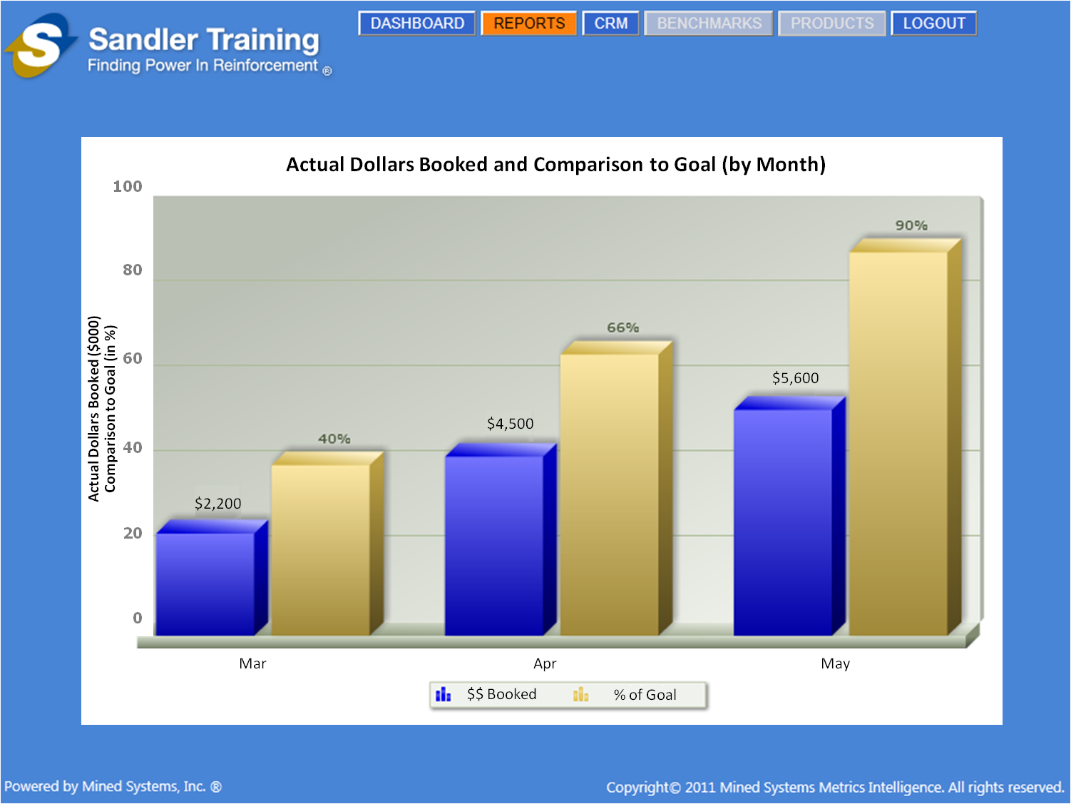

Figure 5‑10: Screen Shot – Actual Dollars Booked and Comparison to Goal (by Month)

### Data required

* The required data for this report will come from the “Sales Pipeline” portion of the CRM Module
* User Total – Actual dollars booked, by user, within each Franchise [by month]
* User Total – Goal of dollars booked, by user, within each Franchise [by month]
* Franchise Total – Summary of actual dollars booked for all users within each Franchise [by month]
* Franchise Total – Summary of goal of dollars booked for all users within each Franchise [by month]
* Region Total – Summary of actual dollars booked for all users within each Franchise, within the Region [by month]
* Region Total – Summary of goal of dollars booked for all users within each Franchise, within the Region [by month]
* Corporate Total – Summary of actual dollars booked for all users within each Franchise, within each Region [by month]
* Corporate Total – Summary of goal of dollars booked for all users within each Franchise, within each Region [by month]

### Data Display by User-Level

* Summary of actual dollars booked and the percent of the goal [by month] as follows:
  + Franchise User
    - Summary of the Franchise User’s actual dollars booked [by month]
    - Percent of the summary of the actual dollars booked by the Franchise User as compared to the Franchise User’s goal [by month]
  + Franchise Owner
    - Summary of all actual dollars booked by all of the Franchise Users within the Franchise [by month]
    - Percent of the summary of actual dollars booked by all of the Franchise Users within the Franchise as compared to the Franchise goal [by month]
  + Coach
    - Summary of all actual dollars booked by all of the Franchises within the Region [by month]
    - Percent of the summary of actual dollars booked by all of the Franchises within the Region as compared to the Region goal [by month]
  + Corporate
    - Summary of all actual dollars booked by all of the Regions [by month]
    - Percent of the summary of actual dollars booked by all of the Regions as compared to the total corporate goal [by month]

## Average Length of Time for Active Clients (by Industry)

This report will initially be a summary report only, but will consist of the “aggregation” of the User, Franchise, and Region data which will be displayed according to the user-level of the individual logged on.

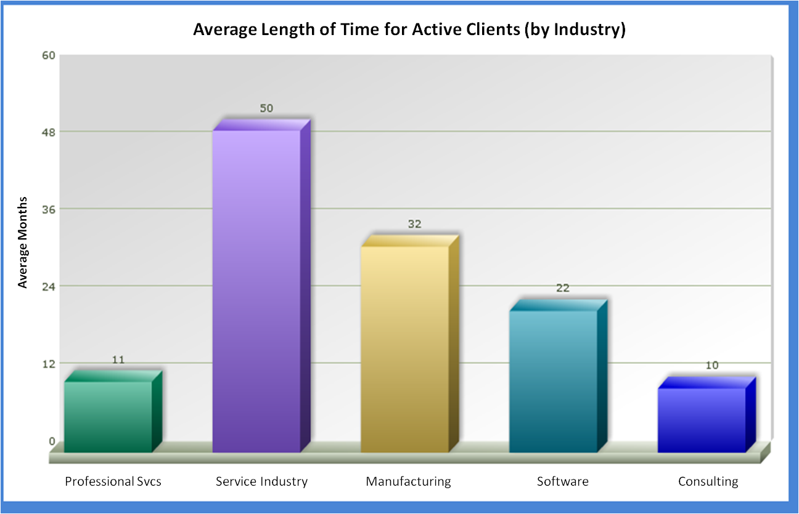

Figure 5‑11: Screen Shot – Average Length of Time for Active Clients (by Industry)

### Data required

* **NEW “Account” CRM MODULE FIELDS NEED TO BE ADDED**
  + Create a date field titled “Account Created”
    - This will indicate that the account has been created and is “active”
  + Create a “drop down” field titled “Industry Type” with the following selections:
    - Professional Services
    - Service Industry
    - Manufacturing
    - Software
    - Consulting
* Franchise User
  + Summary of the average length of time of the Franchise User’s active clients [by industry]
* Franchise Owner
  + Summary of the average length of time of all of the Franchise Users’ active clients [by industry] within the Franchise
* Coach
  + Summary of the average length of time of all of the active clients [by industry] for all of the Franchises within the Region
* Corporate
  + Summary of all of the active clients [by industry] for all of the Regions

### Data Display by User-Level

* Summary of average length of time clients are active for the following Industry Types:
  + Professional Services
  + Service Industry
  + Manufacturing
  + Software
  + Consulting
* Franchise User
  + Summary of the average length of time of the Franchise User’s active clients [by industry]
* Franchise Owner
  + Summary of the average length of time of all of the Franchise Users’ active clients [by industry] within the Franchise
* Coach
  + Summary of the average length of time of all of the active clients [by industry] for all of the Franchises within the Region
* Corporate
  + Summary of all of the active clients [by industry] for all of the Regions

# Benchmark Reports

These reports should be “disabled” for this release of the Sandler application.

# Product Reports

These reports should be “disabled” for this release of the Sandler application.

# Email Functionality

Email functionality is not planned to be included in this release of the Sandler application.

# Logout

When the user logs out of the system, they will be provided with a “logout” screen to show that they have successfully logged out, which also provides the ability for them [or anyone else] to log back into the system.

## Current Logout Screen

The “logout” screen that is presented to the users in the current version of the application [as of the date of this Requirements Document] is shown in the figure below. The wording is not quite accurate and the “LOGIN” button is not in the correct location. This screen needs to be replaced by the screen that is shown in the following section.

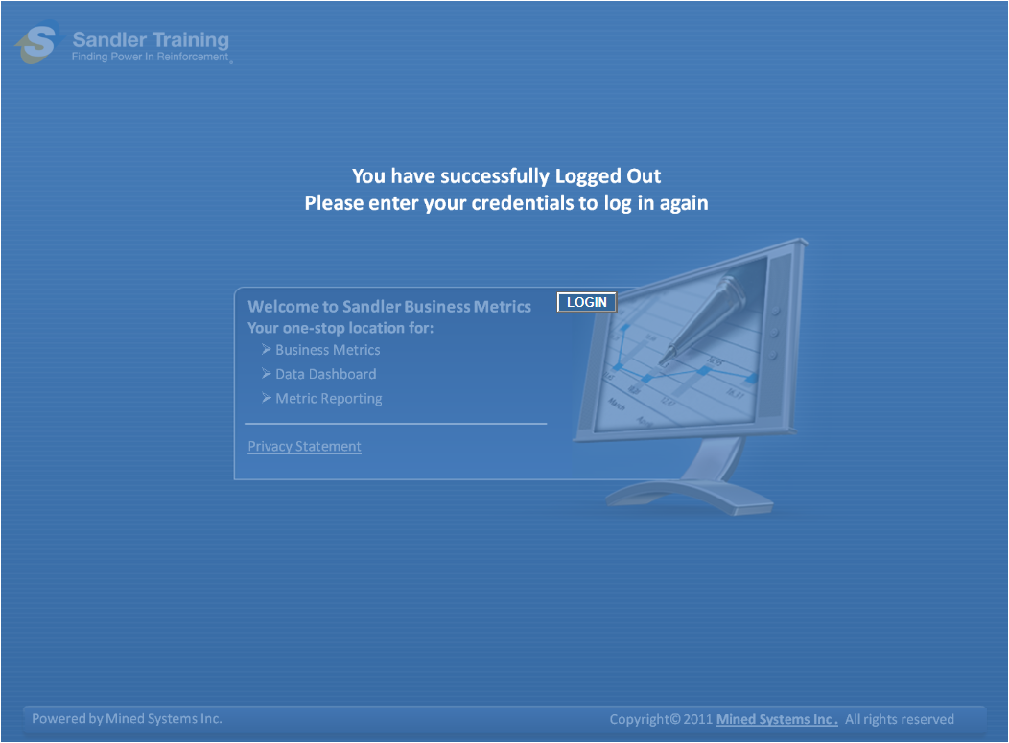

Figure 9‑1: Screen Shot – Incorrect Logout Screen

## Corrected Logout Screen

The screen shown below is how the “Logout” screen should be corrected for this release of the Sandler application. It is merely an “opaque” covering to everything on the existing “Login” pate [with the exception that the “LOGIN” button is still visible and enabled]. In addition, the wording [in white] on the screen provides more explanation to anyone that has logged out.

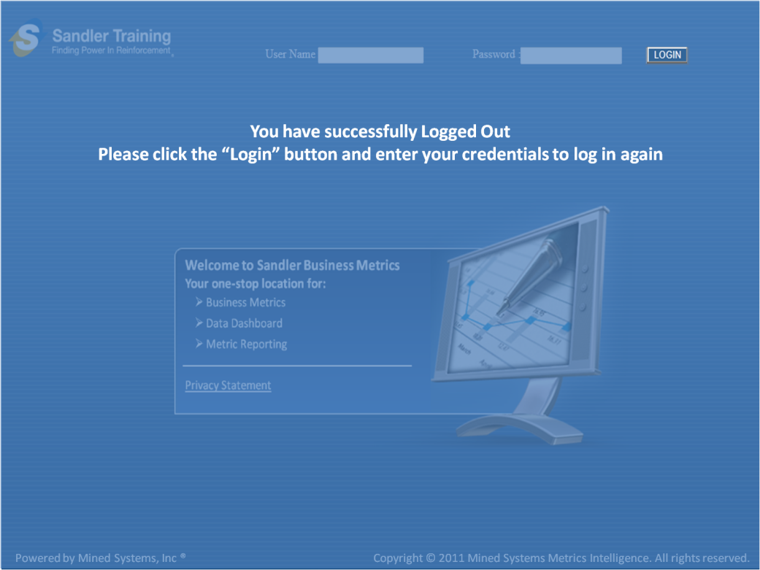

Figure 9‑2: Screen Shot – Correct Logout Screen